Google Hangouts for Teachers: Quickstart Guide!

Overview
“Google Hangouts” video conferences are a superb way of bringing fresh voices into the classroom from anywhere in the world. It was by using Google Hangouts that my students interviewed Professor Orlando Figes at Birkbeck University recently with great success.
• Best of all, the ‘Hangouts on Air’ feature publishes the video directly to YouTube.

What you (and your interviewee!) will need:
• A Google account (sign up at www.google.com)
• A webcam (I have a Logitech C920 HD, which has a great wide-angle, zoomable lens)
• A microphone (the above webcam has one integrated).

Step 1: INTERVIEWER INSTRUCTIONS
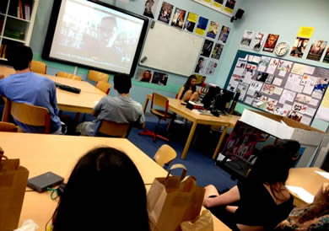
• Log in to your Google account, then click the "[name]+" link at top right to go to your Google+ area.
• On the left, click the drop-down menu and choose 'Hangouts'.
• Select "Start Hangout on Air"
• Click the “Q&A” option to activate it. You can then click the “Q&A” link in the top right of the video preview screen to start adding questions.
• You also get the option to invite people to be the "Audience".
• In the ‘details’ area you can also get a link to the event page and where the YouTube video will be located when it starts.
• These people will not appear in the video, but have the ability to ask questions using the Q&A facility if this is used (e.g. so students can send questions in advance). If you don't need/want an audience, just send an email to a random/fictional address.
• Click 'start', and then you have option to "Invite Guests" - this is the way in which you send an invite to the PARTICIPANT in the chat.
• It will then take a minute to start up before 'start broadcast' appears as an option.

Step 2: INTERVIEWEE INSTRUCTIONS
• Log in to your Google account, then click the "[name]+" link at top right to go to your Google+ area.
• When the 'invitation' comes through an alert should pop up.
• Alternatively, click the 'bell' icon at the top right to see something like 'john smith is video calling you' > 'click to join the video call' (accept terms, click 'join').
• If any problems occur at this stage, shut down the popup window and try again.
• Note: You may be prompted to install a plugin at this stage so that the software can work.

Step 3: INTERVIEWER INSTRUCTIONS
• When the interviewee appears at the bottom right of the screen, you can have a chat with them even before you 'start broadcast'. Note - the Q&A option outlined above has to be activated BEFORE you start broadcast if you wish to use it.
• Once you 'start broadcast' the video is being recorded too and will appear at the end of the chat on your YouTube channel.

TROUBLESHOOTING
• Choppy / unstable video connection: Hangouts put a lot of pressure on your internet connection and as a result the video might occasionally ‘hang’. To address this, hover your mouse in the top center of your screen you will see these tools:
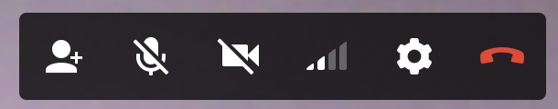
• The fourth one from the left allows you to adjust your ‘bandwidth setting’.
• Distorted audio: The ‘mute microphone’ option (second from left) is useful if you suffer from ‘feedback’ noise (e.g. your own voice echoes back at you because your interviewee has their speakers turned up too loud).

