Escape Room Hint Questions: “Operation Bletchley, 1945”

When there is only 15 minutes of the 45-minute activity, consider giving students the following questions. Successful answers entitle them to a clue about the location of a mission, or a hint about how to complete a mission they’re stuck on. Use them carefully to maintain an appropriate level of momentum!

Sample questions based on some of the sources around my classroom (amend as necessary to reflect your own sources):
According to the pamphlet title, what Battle “is being lost”? (Atlantic)
According to the front page, how many children have still not been evacuated from Greater London? (340,000)
According to the newspaper front page, which two Channel Islands were liberated in 1944? (Jersey, Guernsey)
What date was declared to be “VE Day” in 1945? (May 8)
Name three ways in which bones were used in wartime (glue; fertiliser; soap)

DANGER: UXB
The combination for the lock can be obtained by decoding the following message. The key to this code will be revealed by the FINAL EVENT in the completed timeline.

29294190763788572551

mission DE GAULLE: provide the names of the following world war two figures.

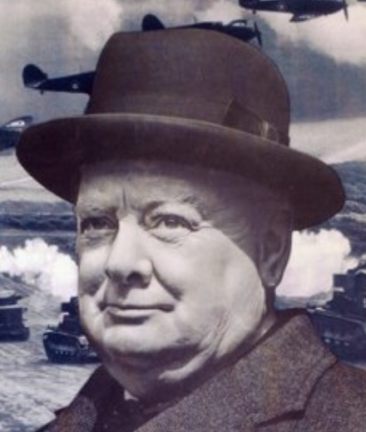 |  | 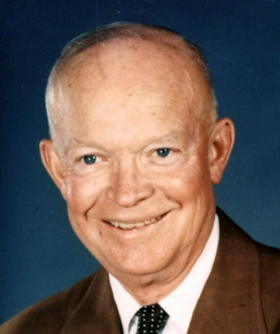
Led Britain to victory in WW2. | Russian fighter pilot | U.S. GENERAL - led the d-day landings against hitler | Soviet dictator during world war two

MISSION STALIN (location: PRINTER TRAY)

Subtract 1940 from the year that World War Two ended.
Use this number to crack this simple substitution cipher and obtain your mission instruction.

HMNQIWJS BJWJ JAFHZFYJI TZY TK HNYNJX YT XFKJYD.

YMJ YBT JAFHZJJX NS YMJ UTXYHFWI FWJ "MFUUD GD YMJ..."?

