Escape Room Mission Slips: “Operation Bletchley, 1945”

Timeline event (give these out one by one as missions are completed, till they have completed all ten and so can crack the code)
1939 (Sep.): Hitler invades Poland. France and Britain declare war. World War Two begins. | [one dozen]
1940 (Jan): Rationing of essential foods is introduced. Children start to be evacuated out of cities like London to be safe from Nazi bombing raids. | [35/4.6]
1940 (Spring): Winston Churchill becomes Prime Minister of Britain. Shortly afterwards, France surrenders to the Nazis. | [2.5*6]
1940 (Summer): Battle of Britain. Planes of the German Luftwaffe try (and fail) to defeat those of the British RAF as the first step towards an invasion of Britain. | [(100-1)/3]
1941 (Summer): Hitler invades Russia. His armies fail to get a quick victory and his winter defeat at the Battle of Stalingrad is a turning point. | [58/6]
1941 (Dec): Pearl Harbor, a US naval base, is bombed by the Japanese (Hitler’s allies). The US enters the war on the Allied side. | [100*0.75]
1942 (January): The “Final Solution” - at the secret Wannsee Conference, Hitler decides to exterminate all Jews in Europe. | [66/3]
1944 (June): D-Day. Allied forces launch a sea-based invasion of France | [9*6/2]
1945 (May): Victory in Europe. Hitler commits suicide. Germany surrenders. World War Two ends. | [41*2]
1945 (August): Victory in Japan. The USA drops atomic bombs on Hiroshima and Nagasaki. | A =*=1st, 4th, 6th, 9th

DANGER: UXB
The combination for the lock can be obtained by decoding the following message. The key to this code will be revealed by the FINAL EVENT in the completed timeline.

29294190763788572551

mission DE GAULLE: provide the names of the following world war two figures.

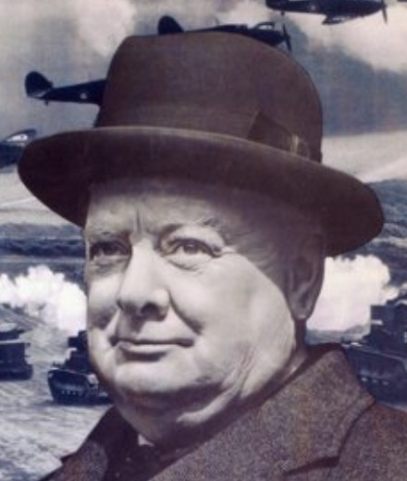 | 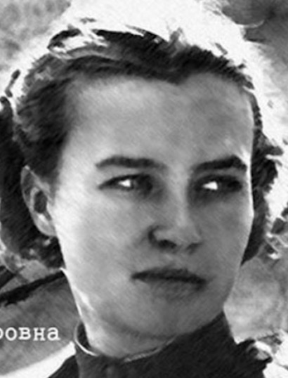 | 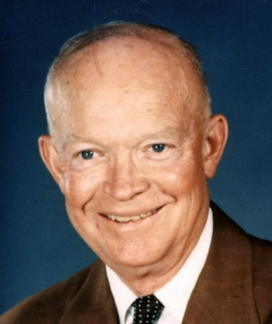 | 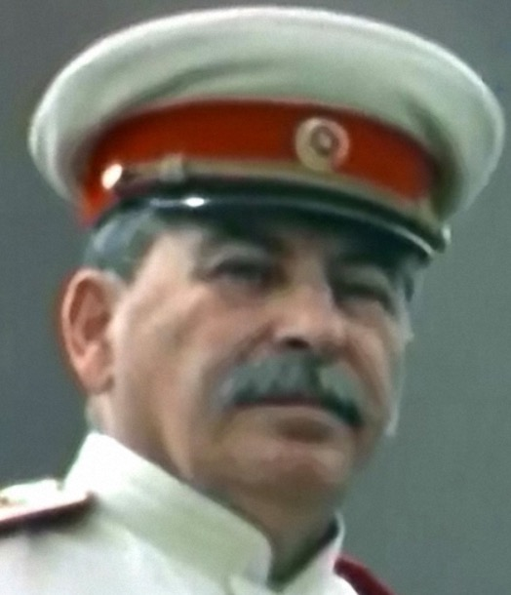
Led Britain to victory in WW2. | Russian fighter pilot | U.S. GENERAL - led the d-day landings against hitler | Soviet dictator during world war two

MISSION STALIN (location: PRINTER TRAY)

Subtract 1940 from the year that World War Two ended.
Use this number to crack this simple substitution cipher and obtain your mission instruction.

HMNQIWJS BJWJ JAFHZFYJI TZY TK HNYNJX YT XFKJYD.

YMJ YBT JAFHZJJX NS YMJ UTXYHFWI FWJ "MFUUD GD YMJ..."?

