Escape Room Mission Slips: “Operation Bletchley, 1945”

Note to teachers: obviously the hiding places for the missions, and the nature of each task, needs to be adjusted for your particular classroom and the sources you have available. Beyond that, you’re limited only by your imagination. The bulk of the sources I used for this activity were in the memorabilia packs I purchased from Amazon (here).

HINT CARDS | Where is it hidden? | Mission Instruction | Mission Answer
Mission Turing: Your mission is in the middle of a newspaper announcing the outbreak of World War Two. | Placed in the middle of the 4th September 1939 newspaper | Mission Turing: Who, as stated by this newspaper, was the British Prime Minister who declared war on Germany on 3rd September 1939? | Neville Chamberlain
Mission Mussolini: You can find this mission behind the image of the man who took over as British Prime Minister in 1940. | Behind the Churchill poster or the Churchill mouse mat on the teacher’s desk | Mission Mussolini: What is the vegetable listed in the "Grow for Winter" leaflet which would be listed last in a dictionary? | Turnip
Mission Petain: The location of your mission is on the other side of the planet: Singapore, a British colony which fell to the Japanese in 1942. | On the reverse of the globe, stuck onto Singapore | Mission Petain: According to the cartoon in the "Better Little Book", women in the WRNS relax by playing table tennis and...? | Darts
Mission De Gaulle: Many British cities were bombed in WW2 during the “Blitz”. The location of your mission too is a little explosive. | Hidden inside the WW1 grenade | Mission De Gaulle: Providing names to go with the images (see overleaf) | Churchill, Meklin, Ike, Stalin
Mission Roosevelt: Stalin of Russia declared war on Nazi Germany in 1941 but has decided to keep your particular mission under his hat. | Inside a Russian hat | Mission Roosevelt: Reconstruct the propaganda poster of RAF pilots. What does Winston Churchill say about them in his quote in the completed image? | Never was so much owed by so many to so few
Mission Stalin: Your mission can be found in the black heart of Adolf Hitler, the Nazi dictator who ruled Germany 1933-45. | In the middle of the black book on Hitler | Mission Stalin: Your mission hasn’t even been printed out yet. | Sea
Mission Churchill: In the “Battle of Britain”, RAF pilots saved the UK from a Nazi invasion. Your mission is in a pilot’s jacket. | In the pocket of the RAF jacket | Mission Churchill: Your aunt is 45 years old. According to this, what is the only job available to her in the WAAF? | Cook
Mission Rommel: “Operation Torch” drove the Nazis out of North Africa. Winston Churchill will shine a light on your next mission. | Written on the Churchill poster in UV pen. | Mission Rommel: The magazine of the Women's Land Army was called...? | The Land Girl
Mission Himmler: British civilians were encouraged to ‘Dig for Victory!’ by growing their own vegetables. Your mission too is planted somewhere rather obvious. | Under a plant pot. | Mission Himmler: In the Civil Defence pamphlet, how many children does it say the government plans to evacuate from the cities in an “enormous undertaking”? | 3 million
Mission Eisenhower: Civilians would watch the skies for the approach of flying bombs called ‘Doodlebugs’. You too will have to look upwards to find your mission. | Taped underneath a desk, or on the ceiling. | Mission Eisenhower: According to War Cookery Leaflet 13, puddings "rather a problem these days" because which two ingredients are rationed? | Sugar and fat

Bonus mission – on acetate, written with a UV pen – outline two planes shown in the Battle of Britain book. These have to be identified by overlaying them on the appropriate Battle of Britain page to get the names of both planes. Basically, once they have completed ten missions, they get their ten timeline pieces. So it’s no problem to create more missions than there are timeline pieces.

DANGER: UXB
The combination for the lock can be obtained by decoding the following message. The key to this code will be revealed by the FINAL EVENT in the completed timeline.

29294190763788572551

mission DE GAULLE: using the sources in the room, provide the names of the following world war two figures.
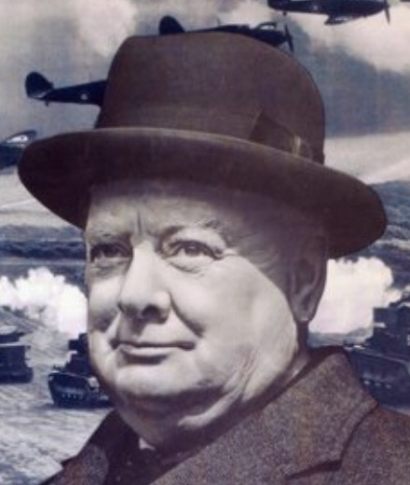 | 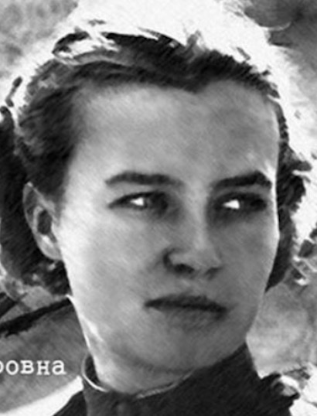 | 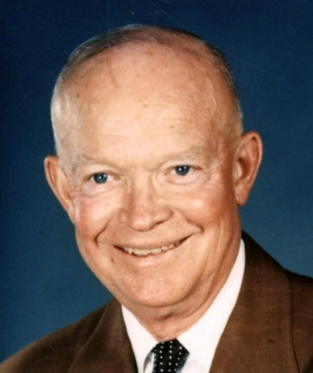 | 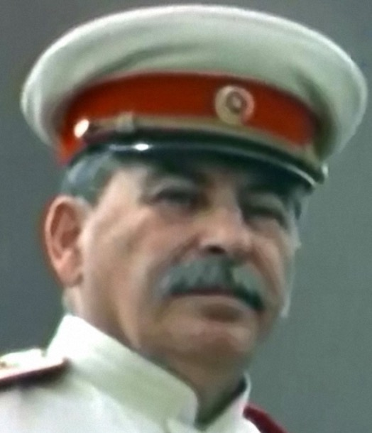
Led Britain to victory in WW2. | Russian fighter pilot | U.S. GENERAL - led the d-day landings against hitler | Soviet dictator during world war two

MISSION STALIN (location: PRINTER TRAY)

Subtract 1940 from the year that World War Two ended.
Use this number to crack this simple substitution cipher and obtain your mission instruction.

HMNQIWJS BJWJ JAFHZFYJI TZY TK HNYNJX YT XFKJYD.

YMJ YBT JAFHZJJX NS YMJ UTXYHFWI FWJ "MFUUD GD YMJ..."?

