Berlin Walking Tour
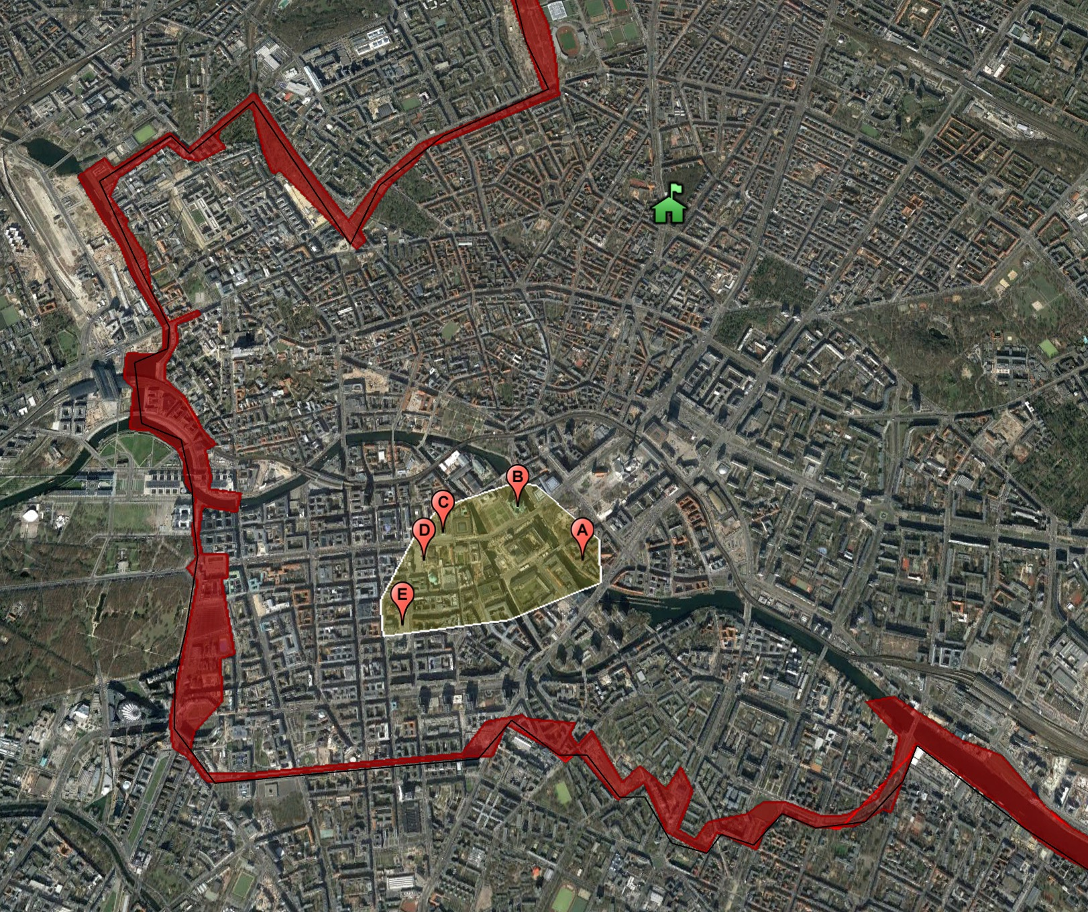
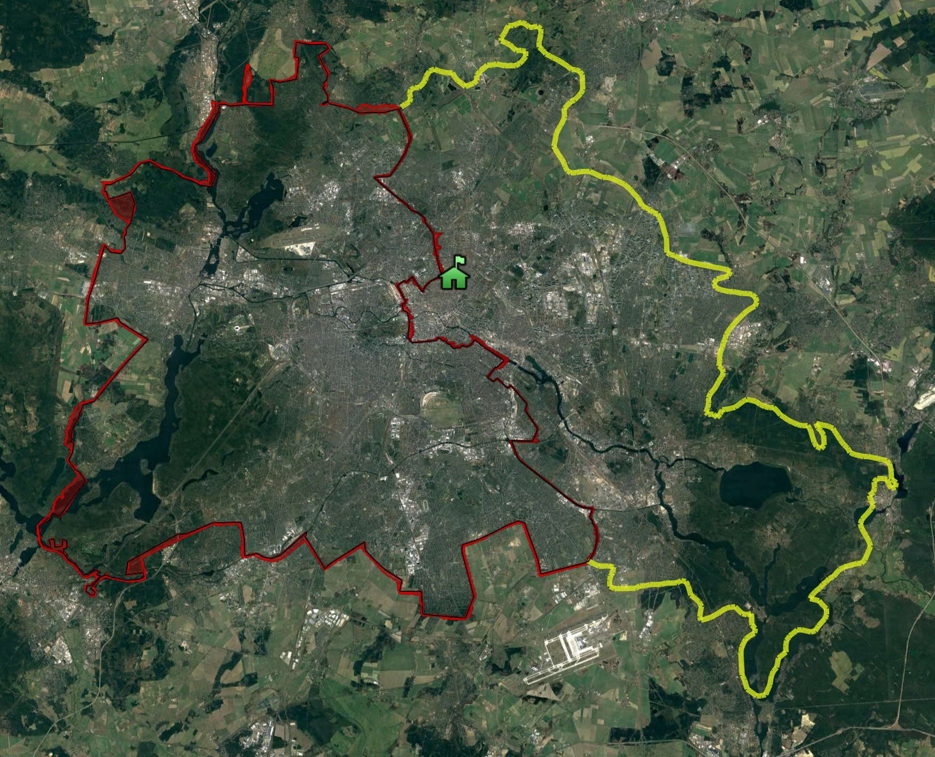
Some (but not all!) of the sites we will visit: A. Nikolaiviertel | B. Berliner Dom | C. Neue Wache | D. BebelPlatz | E. Gendermenmarkt

The Fernsehturm
Visible from almost every part of Berlin (and easily from Nikolaiviertel), the Fernsehturm (television tower) was built as a communist showpiece in the 1960s.
Video: 1961: The Wall is Built / The Fernsehturm (3m) https://vimeo.com/266466156

Q. What was the globe designed to look like, and why?
Q. Why was its nickname is ‘The Pope’s Revenge?’

Nikolaiviertel
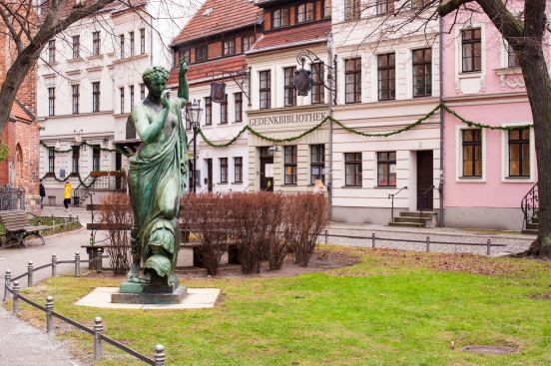
• Founded about 1200, Nikolaiviertel is the medieval heart of Berlin. The Nikolaikirche, Berlin's oldest church, gives its name to the neighbourhood.
• From 1913–1922, Wilhelm Wessel was the pastor in the Nikolaikirche. His son, Horst Wessel, later joined the Nazis and wrote the “Horst Wessel Song” which was adopted as the official anthem of the Hitler Youth after his murder by communists.

Q. How old do you think the buildings are here?
Q. Write the actual answer from your teacher here:

Jewish Synagogue
• As you approach the Lustgarten along the river, you will see in the distance the Jewish synagogue, easily spotted on the skyline with its gold roof.
• Frederick the Great (himself an atheist) welcomed Jews into Germany just as he welcomed French Catholic and Protestant refugees fleeing their homeland due to the Wars of Religion which tore France apart during this period.
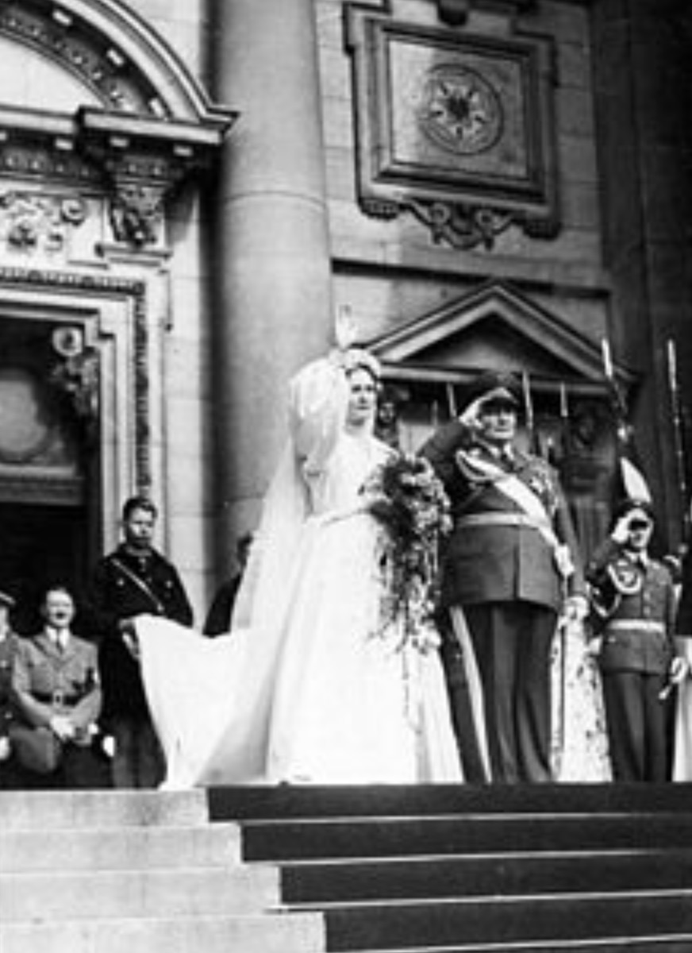
• In the Nazi period the synagogue was set alight by Hitler’s thugs as part of the “Night of the Broken Glass” in 1938 – the concerted vandalism of Jewish shops and monuments. To their credit, the local fire brigade turned up and successfully put out the blaze despite the threats of the Nazi stormtroopers.
• The synagogue was destroyed by Allied bombing in World War Two and was rebuilt following the fall of the Berlin Wall in the early 1990s.

Berliner Dom
• This is the largest Protestant Church in the whole of Germany. It was built by Frederick II “Irontooth” who moved his residence from Brandenburg here in 1451.
• The present structure was built by Wilhelm II. Modelled on St. Peter’s in Rome, inside are statues of Calvin and Luther, the two great Protestant Reformers.
• Hermann Goering, one of Hitler’s most notorious henchmen, was married here in a grand ceremony in 1935. This photo was taken directly outside the main entrance and Hitler can be seen emerging from the door.

Alte Museum
• The Old Museum is the first part of what is now known as Museuminsel (Museum Island).
• Built at the same time as the Louvre in Paris and the National Gallery in London, it was designed to mark Berlin out as a center of European culture.
• The Nazis liked to use it as the venue for some of their largest rallies.
• Like much of the neoclassical architecture of Berlin, this is the work of Friedrich Schinkel:
Video: Schinkel and Berlin (3m) https://vimeo.com/266345361

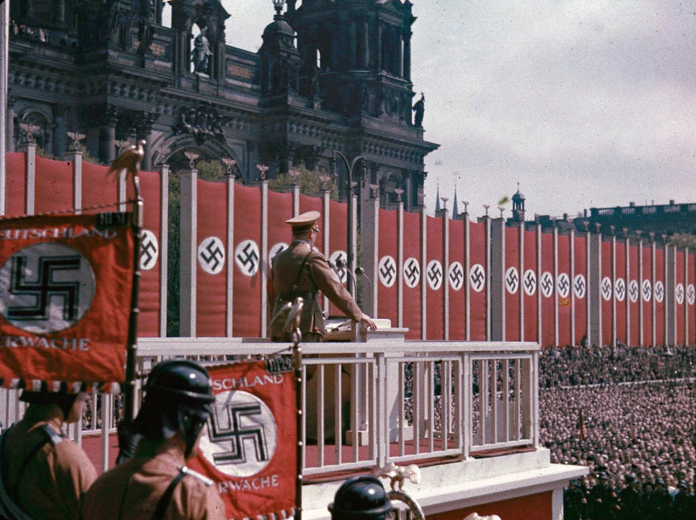
Hitler speaking at a Nazi rally in 1938

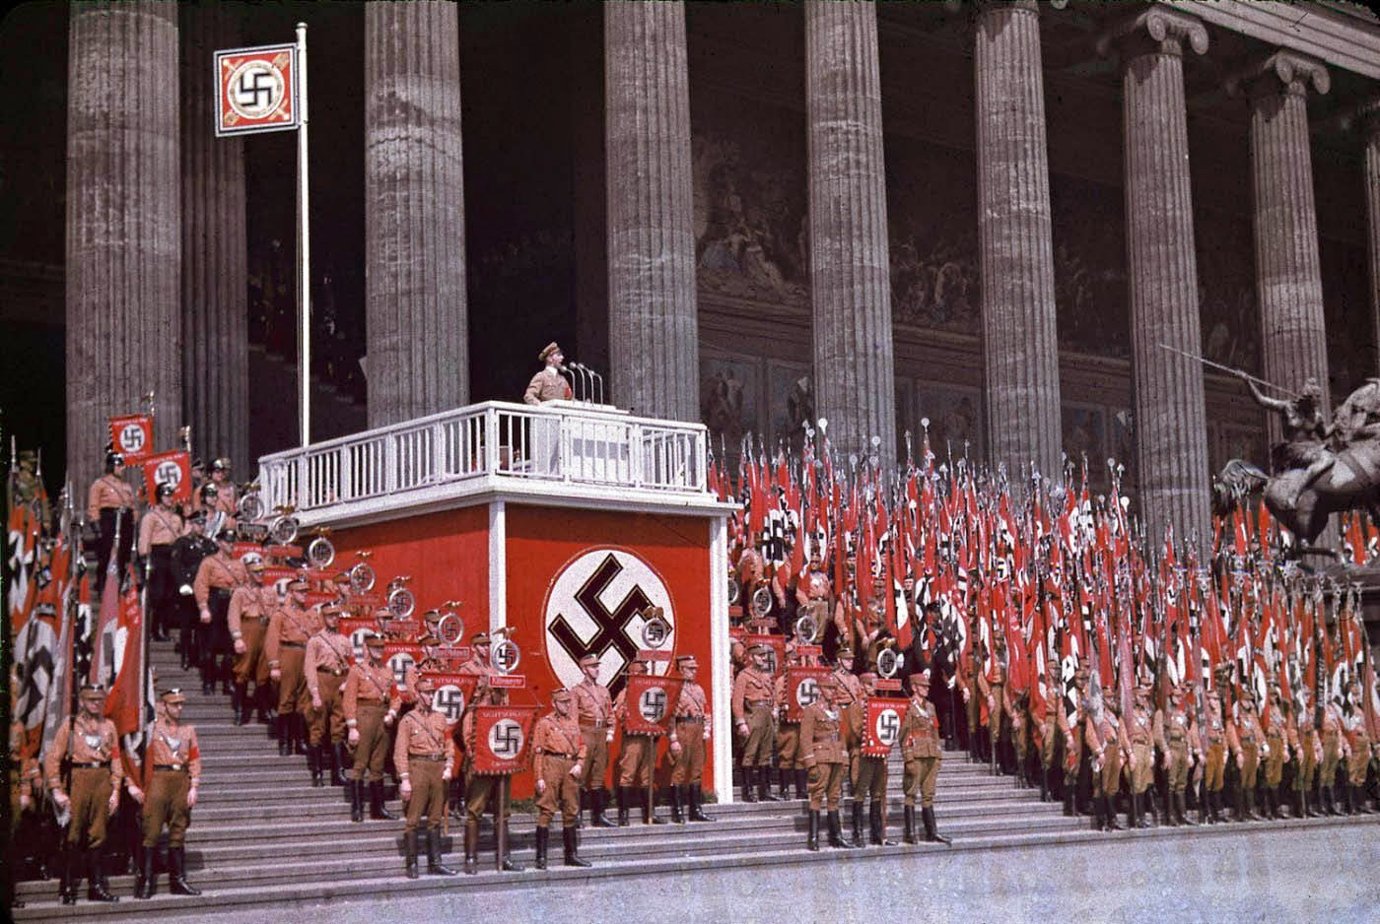
Josef Goebbels, Nazi propaganda minister, speaking at the same event

Berliner Schloss
• Facing the Alte Museum on the opposite side of the main road is the Kaiser’s Palace. This was the residence of the German royal family (Kaiser Wilhelm II was born here; he also declared war in 1914 in a speech from this spot in front of vast crowds).

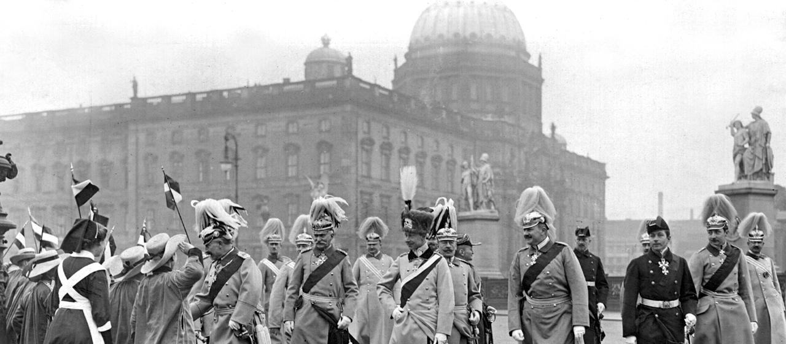

• In 1919, the Spartakists too control of it and Liebknecht declared Germany to be a communist republic. After they were driven out, the palace was converted during the Weimar period into a public museum.

• After World War Two the communists demolished it with massive blasts of dynamite. The area then lay barren until 1976, when a new communist “Palace of the People” was unveiled by the East German leader, Erich Honecker. A striking building with a golden mirrored surface, it was known as ‘Erich’s Lamp Shop’ due to the thousands of lights which hung from its ceiling.

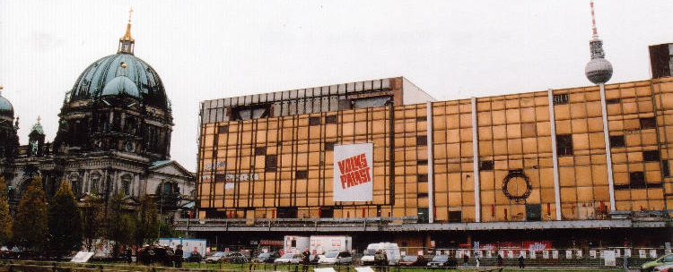

• After the fall of the Berlin Wall, there was a great debate about whether this monument to communism should be allowed to stand or be replaced with a reconstruction of the Old Palace.
- Pro-reconstruction lobby groups argued that the rebuilding of the Stadtschloss would restore the unity and integrity of the historical centre of Berlin, which includes the Berliner Dom, the Lustgarten and the museums of Museum Island.
- Opponents of the project included those who advocated the retention of the Palast der Republik on the grounds that it was itself of historical significance; those who argued that the area should become a public park; and those who believed that a new building would be a pastiche of former architectural styles; would be an unwelcome symbol of Germany's imperial past; and would be unacceptably expensive for no definite economic benefit.

Q. What way would you have voted and why?

Q. Your teacher will now tell you what actually happened. Make notes here:

Q. What should go on top of the new dome?

Discussion point: Nearby is the “Humboldt Box” which outlines the concept for the Schloss and its future use. The Tagesspiegel called the Humboldt Box "an architectural monster in galactic proportions”. Do you agree?

Video: The Schloss under the communists (7m) https://vimeo.com/266466151
Video: Debate over the future of the palace (3m) https://vimeo.com/266345347

Neue Wache
• Dating from 1816, the Neue Wache (New Guardhouse) was originally the guardhouse to the City Palace and a memorial to the soldiers that had lost their lives in the wars against the French Emperor Napoleon in the years before.
• On 1 August 1914 the mobilization order for World War I was proclaimed there, as was the demobilization order on 11 November 1918.
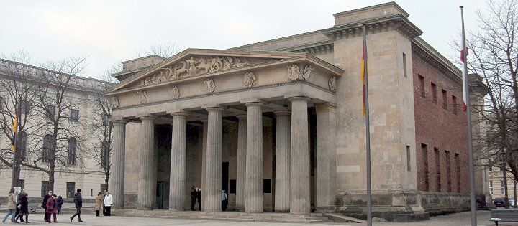
• Its purpose has been redefined over time with a bewildering aray of re-dedications:
- Memorial of the Prussian State Government (<1918)
- Memorial Site for the Fallen of the World War (1918-45)
- Memorial to the Victims of Fascism and Militarism (1945-1990)
- Memorial for the Victims of War and Dictatorship (>1990)

Memorial for the Fallen of the World War (1918-45)

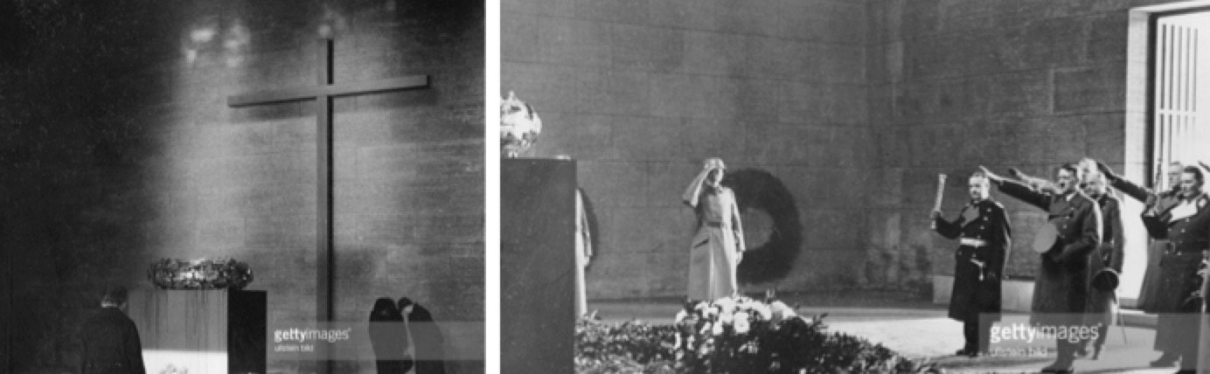
Neue Wache in the 1930s: A gilded wreath lies before a Christian cross. On the right, Hitler and Goering salute at a remembrance ceremony.

Memorial to the Victims of Fascism and Militarism (1945-1990)

Q. What sort of features could be incorporated into a memorial focusing on the victims of Fascism and militarism?
Q. Your teacher will now tell you the actual answer. Write notes here.
Q. Do you think these were good ideas? Why?
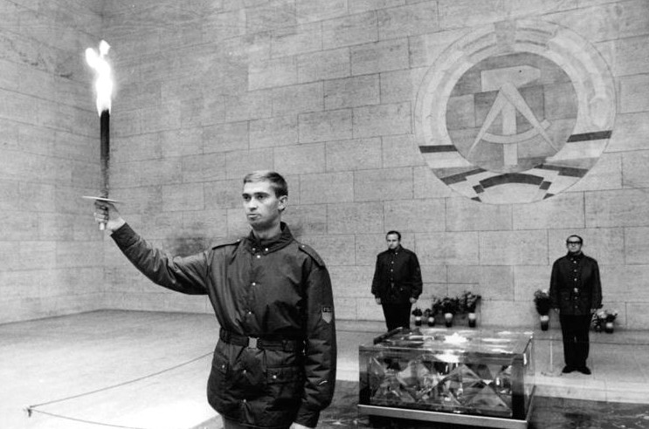
Neue Wache in 1970

Memorial for the Victims of War and Dictatorship (>1990)
• Following reunification, it was decided to rededicate the monument as a memorial to the Victims of War and Dictatorship. A debate then took place about what sculpture could be placed in the central area.

Q. What style of sculpture would you think is most appropriate? Why?
Q. Now go inside and take a look at the sculpture. What are your thoughts about it? Is it an appropriate focal point for a memorial of this nature? Why?

Statue of Frederick the Great
• In front of the university is a statue of Frederick the Great on horseback, facing down the main road – the Unter den Linden. This road leads to the Brandenburg Gate and the royal hunting grounds, which is now the Tierpark.
• During WW2, it was encased in concrete to protect it from bombing; this was removed in 1950 and the communists then moved the statue to Potsdam as they saw Frederick as a military dictator. But they later reinstated it to give them historical legitimacy, stressing instead his cultural (and atheistic) credentials.

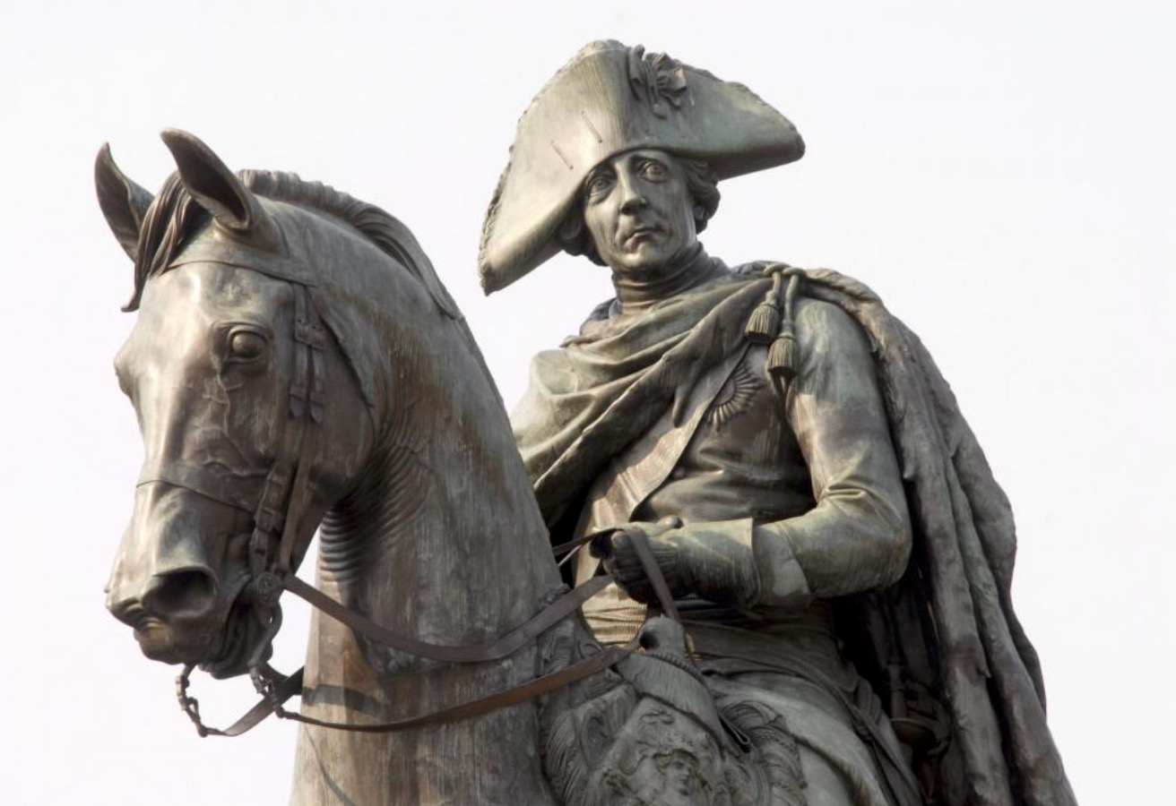
Video: The Frederick the Great statue in the 1970s https://vimeo.com/266466134 (4m)

Humboldt University
• Established in the early 19th Century, Humboldt University (named after the two Enlightenment brothers) is often described as the first modern university in the sense that it pioneered a research-based approach to education and gave equal weight to both the arts and the sciences.
• Its alumni include Einstein, Marx and Engels, Bismarck, Karl Liebknecht, WEB Du Bois, European unifier Robert Schuman, and G.W.F. Hegel.
• National Socialism left deep marks on the Berlin University. Numerous Jewish academics and students were dismissed or ex-matriculated from the University, and members of the University took part in the Book Burning on 10 May 1933. In the light of this history and the position of the University in the centre of the democratic surroundings of the German capital, the present-day Humboldt-Universität zu Berlin sees itself obligated to continually critically examine its position in politics and society.
• One of the ways it does this is by having a regular book sale near its entrance, which takes over all of Bebelplatz in a major event each year!

Q. Take a look at this picture of Alumni of the university. How many can you name? Add the correct names around the image after discussion.

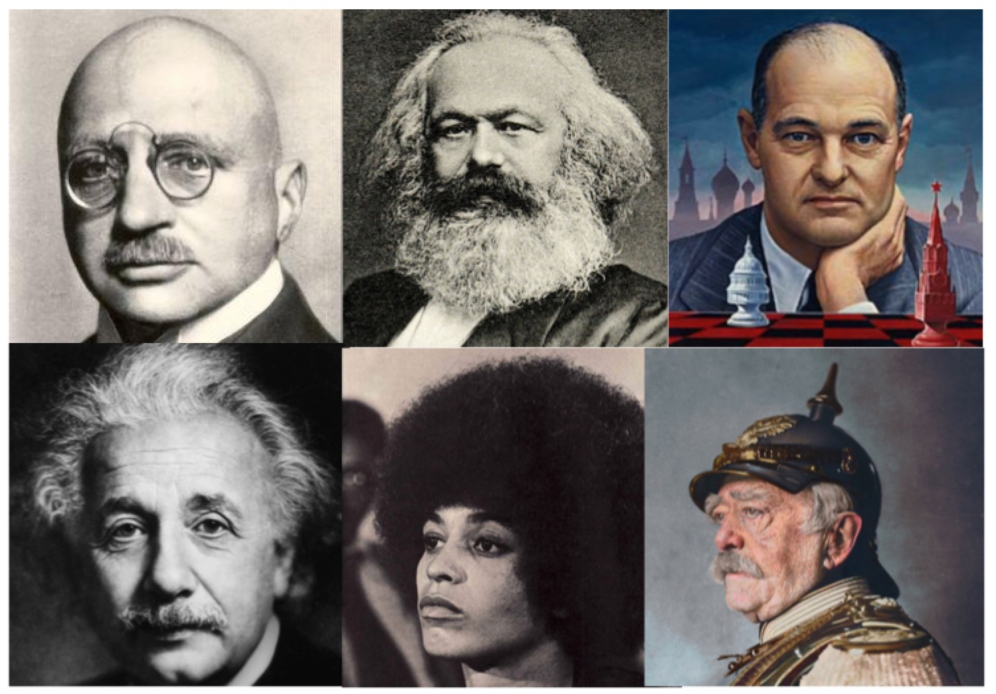

Bebelplatz
• This square, designed in the reign of Frederick the Great, features St. Hedwig's Cathedral, the first Catholic church built in Prussia after the Reformation. The square is named after August Bebel, a founder of the Social Democratic Party of Germany in the 19th century.
• The Bebelplatz is known as the site of one of the infamous Nazi book burning ceremonies held in the evening of 10 May 1933 in many German university cities. The book burnings were initiated and hosted by the nationalist German Student Association. The library of Humboldt University was ransacked and thousands of books by "degenerates" and opponents of the regime were taken to be burned here in a demonstration featuring a speech by Joseph Goebbels. Besides other spectators, it was attended by members of the Nazi Students' League, the SA ("brownshirts"), SS and Hitler Youth groups. They burned around 20,000 books, including works by Heinrich Mann, Erich Maria Remarque, Heinrich Heine, Karl Marx, Albert Einstein and HG Wells:

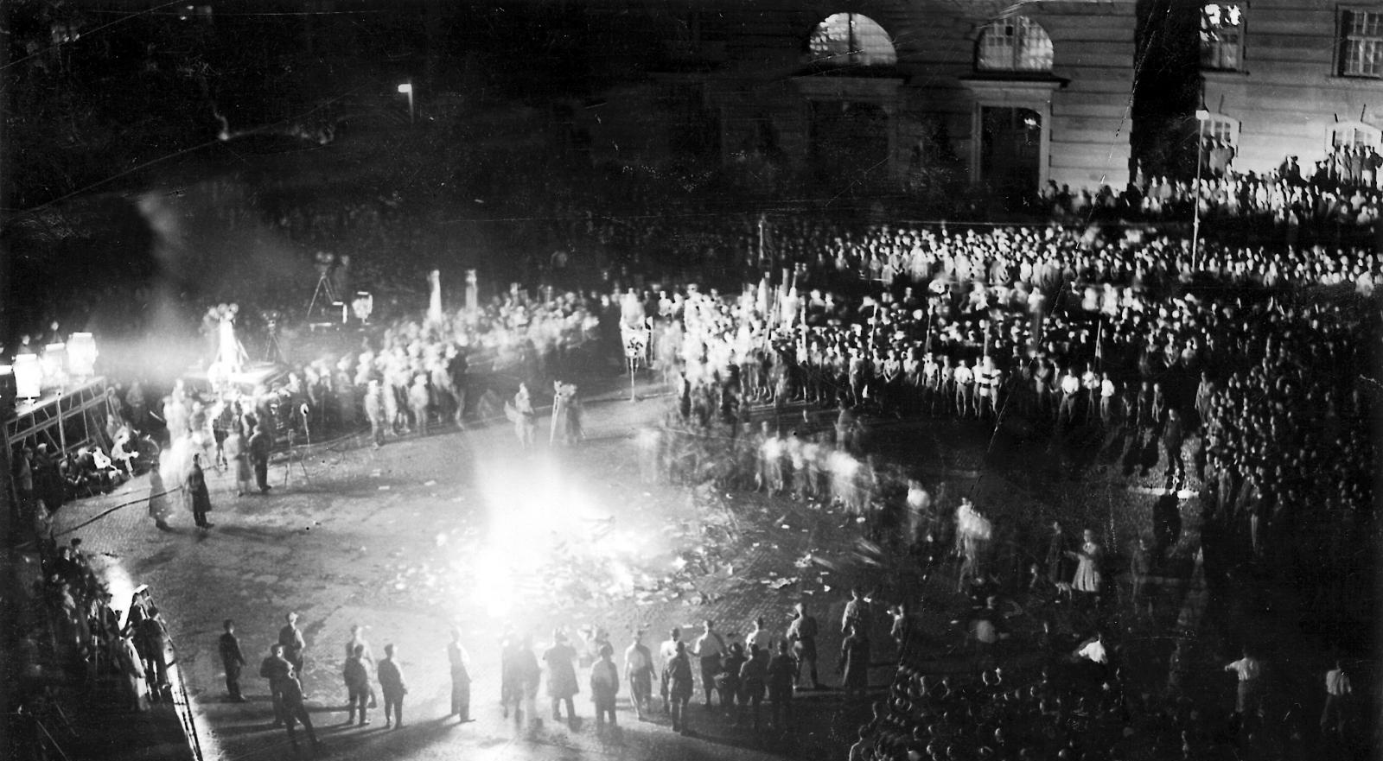

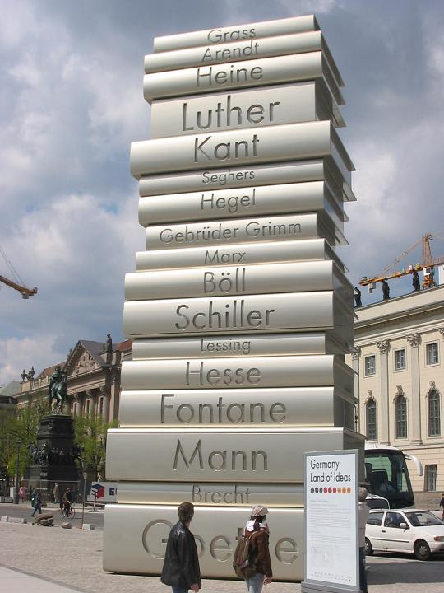
• A monument to this event can now be found in the center of the square, consisting of a glass panel opening onto an underground white room with empty shelf space for 20,000 volumes and a plaque, bearing an epigraph from an 1820 work by Heinrich Heine: "This was but a prelude; where they burn books, they ultimately burn people". Students at Humboldt University hold a book sale in the square every year to mark the anniversary.

Video: Book Burning at BebelPlatz (1m) https://vimeo.com/266345409

• The existing monument is felt by many to be rather underwhelming. More attractive was the Walk of Ideas, which was a set of six sculptures in central Berlin designed by Scholz & Friends for the 2006 FIFA World Cup football event in Germany. One of these was a 40ft stack of books sculpture, commemorating the invention of modern book printing.

• What follows is the full list of names on each spine, beginning with the topmost book.

Q. How many of the following names, listed on the monument, have you heard of? Have any of you even read works by any of them?

- Günter Grass
- Hannah Arendt
- Heinrich Heine
- Martin Luther
- Immanuel Kant
- Anna Seghers
- Georg Wilhelm Friedrich Hegel
- The Brothers Grimm
- Karl Marx
- Heinrich Böll
- Friedrich Schiller
- Gotthold Ephraim Lessing
- Hermann Hesse
- Theodor Fontane
- Thomas and Heinrich Mann
- Bertolt Brecht
- Johann Wolfgang von Goethe

St. Hedwig’s Cathedral
• Opened in 1773, this was the first Catholic church built in Prussia after the Reformation. The building was modelled on the Pantheon in Rome.
• After the Kristallnacht pogroms that took place on the night of 9–10 November 1938, Bernhard Lichtenberg, a canon of the cathedral chapter of St Hedwig since 1931, prayed publicly for Jews at evening prayer. Lichtenberg, who had earlier been attacked by Goebbels for encouraging his flock to watch the anti-war film "All Quiet on the Western Front" was later jailed by the Nazis and died on the way to the concentration camp at Dachau.
• In 1965, Lichtenberg's remains were transferred to the crypt at St. Hedwig's.

Gendarmenmarkt
• This beautiful square was built by Frederick the Great. Its main residents were Huguenot refugees from France, which is why the French Protestant community was given one church on the square, and the Lutheran congregation the other.
• The other main feature of the square is the opera hall.
• With its cultural and military connections, it is a perfect symbol of the divided nature of Berlin and the German national character.
• It was badly bombed during the Battle of Berlin in 1945 and restored afterwards.

Q. Can you locate the spot where Photo 1 was taken and recreate it?

In the center of Gendermenmarkt is a statue of poet Friedrich Schiller, whose poem "Ode to Joy," set to music by Beethoven, is the EU's anthem. So it was chosen as the location of a pro-EU rally involving 6,000 people in March 2017. And in 2016, the Konzerthaus was decorated with 14,000 orange life vests to highlight the refugee crisis (Photo 2).

Photo 1 | Photo 2
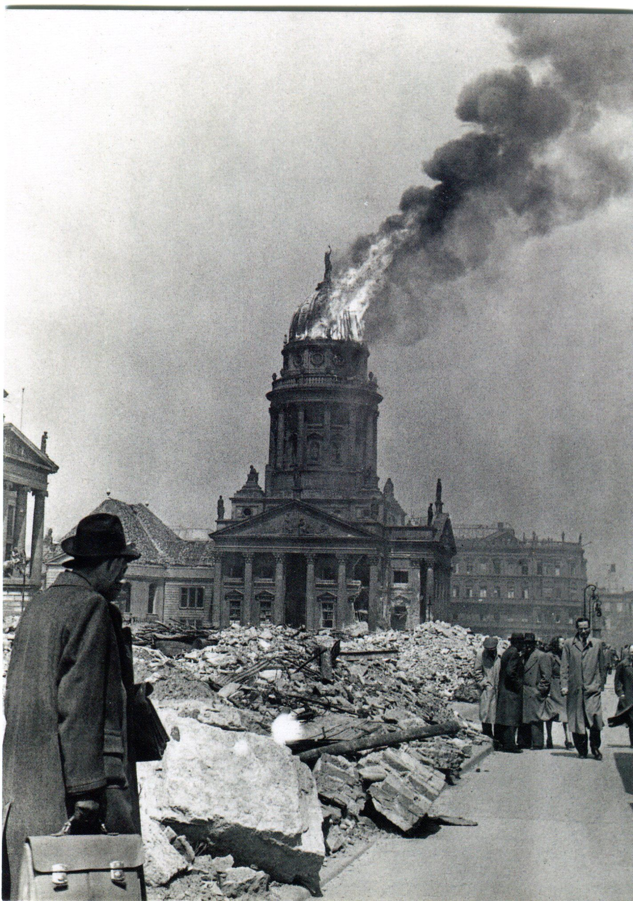 | 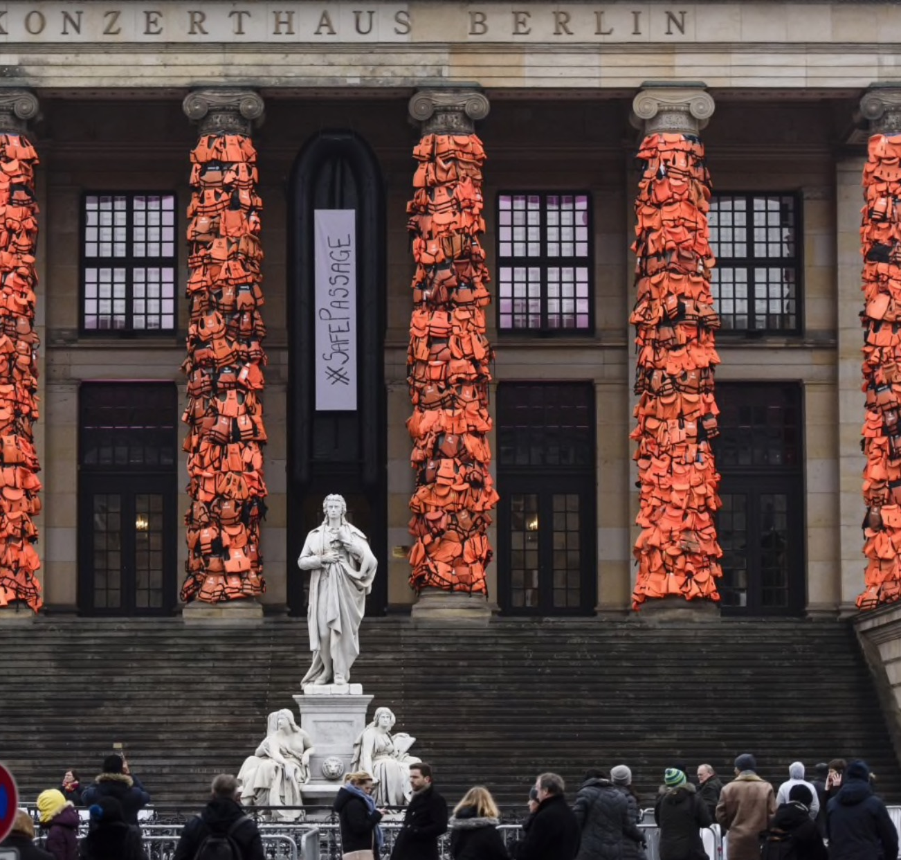

Discussion Points
1. Do you know the tune of Ode to Joy?
2. One concern raised by a journalist who attended the pro-EU demonstration is that protests like this only ever attract people who support them anyway, so they are a waste of time. What’s the solution then to this problem?

