Berlin: Introduction and Overview

Early Modern History
• Berlin was established in the Middle Ages on the river Spree and became the capital of Prussia, whose most famous King was Frederick the Great (1712-1786). Known as “Fritz”, he was a complex man, obsessed equally but uneasily with culture and violence, with liberalism and militarism. On the one hand he was an accomplished musician, poet and philosopher (he counted Voltaire among his closest friends). On the other he was a brutal military genius
(the Brandenburg Gate is a tribute to his triple victories over France, Austria and Russia).
Video: Frederick the Great - Berlin Personified (7m): https://vimeo.com/266466141

Weimar and Nazi Germany, 1918-45
• Following the Franco-Prussian War of 1870-71, the King of Prussia became Kaiser of a unified German state. However, this “Kaiserreich” (Empire of the Kaisers) was dismantled after World War One. Kaiser Wilhelm II was forced to abdicate and as a condition of the armistice Germany agreed to implement a new, democratic constitution.
• The history of modern Germany therefore veered from the authoritarianism of the Kaisers to the radical democracy of the Weimar Republic (1918-33). The Great Depression of 1929-33 propelled another swing of the political pendelum, with Hitler becoming Chancellor in 1933 as the first step to creating the Nazi dictatorship of the Third Reich (1934-45).
• This historical schizophrenia ended with the total destruction of Berlin at the end of World War Two in 1945: the country was then divided between a communist East German dictatorship and a liberal West German democracy.

The Cold War
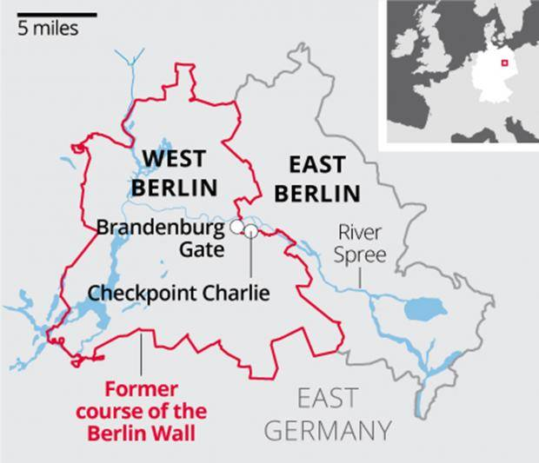
• Berlin mirrored this post-war division in a particularly bizarre way. The city itself was situated deep within communist East Germany, but its importance meant that the Western half of the city remained under control of the USA and its allies (France and Britain). West Berlin was a democratic island deep inside the Soviet Empire. In the years following the war, thousands of Europeans trapped behind the “Iron Curtain” simply headed into West Berlin and then escaped by its rail, road or air routes to freedom.
• Stalin tried (and failed) to force the allies out of the city and close this gap in the “Iron Curtain” during the Berlin Blockade (1948-49). The “brain drain” was finally ended when the East German government built a wall around the entire border of West Berlin in 1961. At a stroke, access to West Berlin from East Germany was cut off except by special permission and at 12 designated crossing points (the most famous being Checkpoint Charlie, situated as it was right in the city center near the Brandenburg Gate).
• In the subsequent years, the Berlin Wall became the ultimate symbol of the “Iron Curtain” separating the communist world of the USSR and the and capitalist world of the USA. Many people mounted daring escapes over (and under) the wall, and many others were tragically shot dead by East German border guards whilst making the attempt.
• The wall eventually collapsed along with the USSR in 1989-90, with Berlin and Germany subsequently being re-unified once more.

