**“Sarajevo Sandwich Syndrome”**

**Questioning the Reliability of Historical Sources**

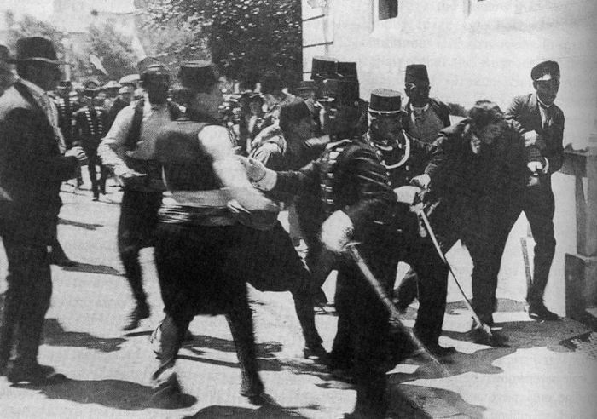• Historians must always question the reliability of the sources they use.

• Some sources obviously need to be treated with care: diaries are subjective, propaganda is one-sided, feature films are designed to entertain, not educate.

• Other sources tend to be accepted without too much interrogation: the camera never lies, textbooks are balanced, documentary films are designed to inform, not persuade.

• However, it is dangerous to assume that certain types of source are automatically more or less reliable than others. Each source should be judged on its own particular merits.

**Case Study: BBC TV: “Days that Shook the World - Sarajevo, 28th June 1914”**

• One of the most popular classroom resources covering the assassination of Franz Ferdinand is an episode from the award-winning series “Days that Shook the World”

• At face value this 30-minute film should be highly reliable: it is a documentary (rather than a feature film), produced by the highly respected British Broadcasting Corporation.

• However, there are a number of assertions made in this source which are contentious.

**Task**

• Your task is to investigate six assertions made by the documentary. For each one, determine whether it is:

* Incorrect: Other vidence contradicts the documentary
* Inconclusive: Other evidence shows that historians disagree about this point
* Imaginary: No evidence can be found which backs up this point

• Write your findings in the **one** appropriate column for each statement.

• TIP: There are two statements which are incorrect, two inconclusive, and two imaginary.

|  |  |  |  |
| --- | --- | --- | --- |
| **Statement made in the documentary** | **Incorrect?** | **Inconclusive?** | **Imaginary?** |
| [Provide the correct version of events here] | [Explain what historians disagree about] | [Simply state ‘no evidence exists to substantiate this’] |
| Colonel Dimitrijević was nicknamed ‘Api’ because this means “the bee” in Serbian (the reason for this nickname is not explained). |  |  |  |
| The “Black Hand” were funded by the Serbian government (“state-sponsored terrorists”). |  |  |  |
| Franz Ferdinand scheduled the trip to Sarajevo on the 28th June with his wife because it was their wedding anniversary. |  |  |  |
| The Archduke’s wife had recently told him that she was pregnant with their fourth child. |  |  |  |
| At the time that the Archduke’s car stopped in front of Princip, he was eating a sandwich. |  |  |  |
| The famous photo taken at the scene captures the moment that Princip was arrested. |  |  |  |

Teacher note: An alternative approach is to set different students work on different statements and report back with their findings in a subsequent lesson.

**Teacher notes**

|  |  |  |  |
| --- | --- | --- | --- |
| **Point made in the documentary** | **Incorrect?** | **Inconclusive?** | **Imaginary?** |
| Colonel Dimitrijević was nicknamed ‘Api’ because this means “the bee” in Serbian (the reason for this nickname is not explained, however) |  | Historians disagree about whether his nickname comes from the Latin 'the bee' because he was so hardworking, or 'the bull' because he was physically imposing. |  |
| The “Black Hand” Gang were sponsored by the Serbian government (“state-sponsored terrorists”) |  | The Black Hand were directly connected to Colonel Api. Whether Api himself was acting on the direct orders of the Serbian government remains unclear. |  |
| Franz Ferdinand scheduled the trip to Sarajevo on the 28th June with his wife because it was their wedding anniversary. | Their anniversary was actually on 1st July. |  |  |
| The Archduke’s wife had recently told him that she was pregnant with their fourth child |  |  | No evidence can be found to support this argument. |
| At the time that the Archduke’s car stopped in front of Princip, he was eating a sandwich |  |  | No evidence can be found to support this argument. |
| The famous photo taken at the scene captures the moment that Princip was arrested | The photo actually shows a man called Ferdinand Behr, who was arrested because he tried to stop a mob on the pavement from beating Princip to death. |  |  |

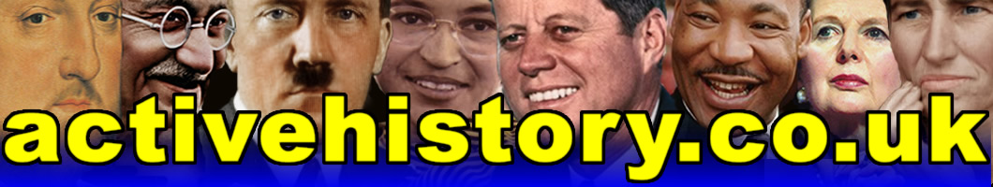

***Transform your history classroom***