Head2Head Interview Challenge
Winston Churchill: Hero or Villain?

In the last lesson, you analysed quotes BY Winston Churchill. In this part of the investigation you will do look at more detailed sources ABOUT Churchill.

Task 1: Reading the sources (c.25m)
Use green to highlight positive points, and red to highlight negative points, about Churchill, in the sources overleaf. Explain your choices in the second column each time (the first one is done for you).
NOTE: You do NOT have to consider ALL the quotes if you do not have time to do so. Stop this process after 25 minutes to leave yourself enough time for Task 2.

Task 2: Writing the THIRD paragraph of your essay (c.25m)
Use what you have now learned to develop this paragraph as well as you can in the remaining time of the lesson.

“The opinions of people who personally knew and worked with Churchill are another very useful source of evidence about whether he deserves to be remembered as a hero or a villain.
• Some of these people clearly regarded Churchill as a hero. One such person was [name of witness]. They said of Churchill that “…”. This suggests that Churchill was …. because … (repeat this format for as many quotes as you wish)
• However, other witnesses had a more mixed impression. One such person was [name of witness]. They said of Churchill that “…”. This suggests that Churchill was …. because … (repeat this format for as many quotes as you wish)
• Moreover, other witnesses clearly disliked Churchill. One such person was [name of witness]. They said of Churchill that “…”. This suggests that Churchill was …. because … (repeat this format for as many quotes as you wish)
• Nevertheless, historians realize that there are limitations to the reliability of sources like these. For example …” (offer some thoughts about why some of these witnesses might be more reliable, fair and accurate than others)

The Sources

 |  | Positive  HERO | Negative  VILLAIN
 | "Keep your eye on Churchill" should be the watchword of these days. Remember, he is a soldier first, last and always. He will write his name big on our future. Let us take care he does not write it in blood.'  A.G. Gardiner, historian, writing in 1914. | Brave (“he is a soldier”) | Bloodthirsty (“write it in blood”)
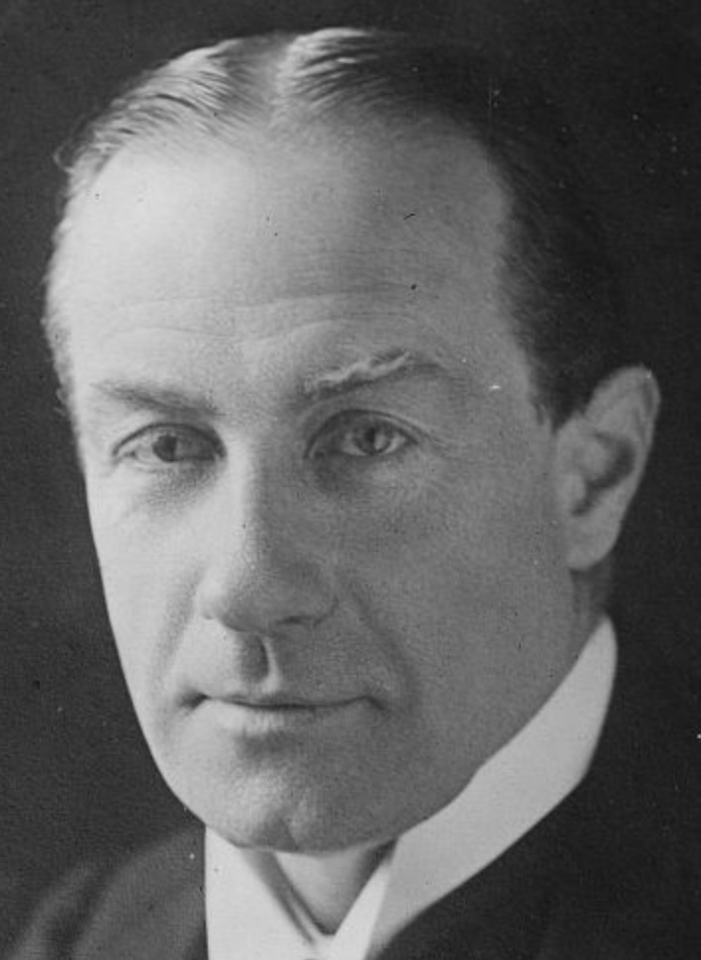 | When Winston was born lots of fairies swooped down on his cradle with gifts, imagination, eloquence, industry, ability; and then came a fairy who said, 'No one person has the right to so many gifts,' picked him up and gave him such a shake and twist that with all the gifts he was denied judgment and wisdom.  Prime Minister Stanley Baldwin, 1926
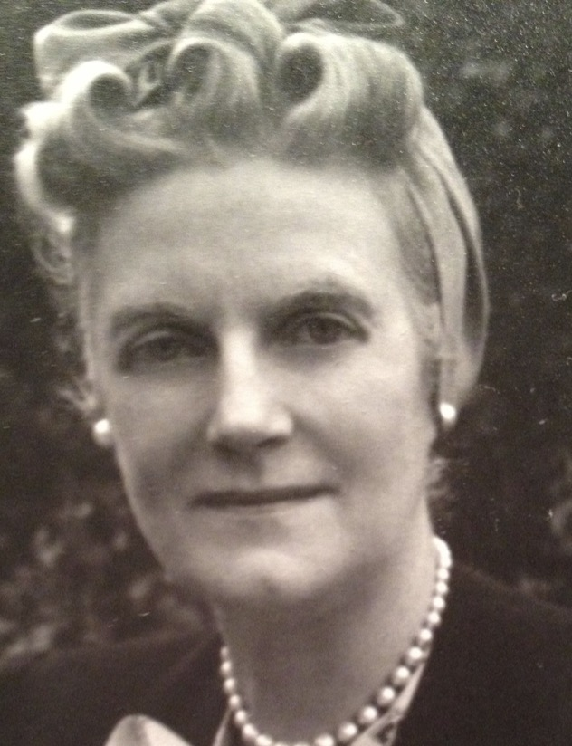 | My Darling, I hope you will forgive me if I tell you something that I feel you ought to know. One of the men in your entourage (a devoted friend) has been to me & told me that there is a danger of your being generally disliked by your colleagues and subordinates because of your rough sarcastic & overbearing manner…I was told 'No doubt it's the strain'. My Darling Winston - I must confess that I have noticed a deterioration in your manner & you are not so kind as you used to be… I cannot bear that those who serve the Country and yourself should not love as well as admire and respect you…  Churchill’s wife, Clementine, writing to Churchill in 1940
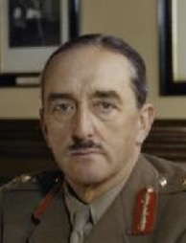 | Winston had ten ideas every day, only one of which was good, and he did not know which it was… Without him England was lost for a certainty, with him England has been on the verge of disaster time and again...... Never have I admired and despised a man simultaneously to the same extent. Never have such opposite extremes been combined in the same human being.  Lord Alanbrooke. 1945
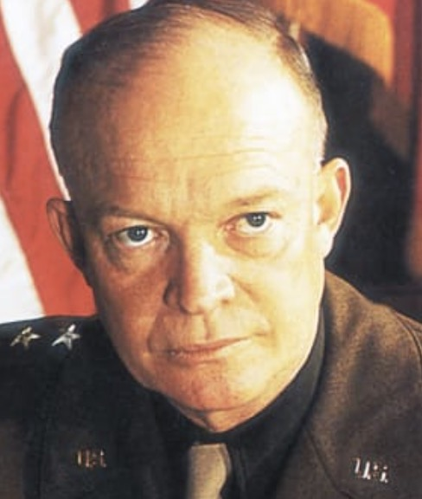 | An inspirational leader, he seemed to typify Britain's courage and perseverance in adversity and its conservatism in success. He was a man of extraordinarily strong convictions and a master in argument and debate. Completely devoted to winning the war and discharging his responsibility as Prime Minister of Great Britain, he was difficult indeed to combat when conviction compelled disagreement with his views….He used humor and pathos with equal facility, and drew on everything from the Greek classics to Donald Duck for quotation, clich', and forceful slang to support his position. I admired and liked him.  President Eisenhower, 1965
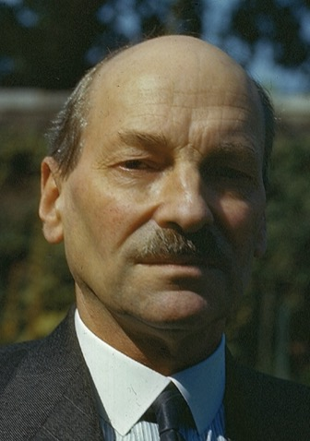 | His greatest virtue, his compassion, has never properly been appreciated. It was his compassion, coupled to his energy, that made him so “dynamic.” Cruelty and injustice revolted him. But if Winston’s greatest virtue was his compassion, his greatest weakness was his impatience. He never understood that a certain time was always bound to elapse between when you ask for something to be done and when it can be effected. He worked people terribly hard, and was inconsiderate. On the whole, he did not vent his impatience on people in bursts of temper or in bullying. But, as Alanbrooke has reported in his Diaries, he kept people working impossible hours.  Clement Attlee, a member of Churchill’s government, in 1945
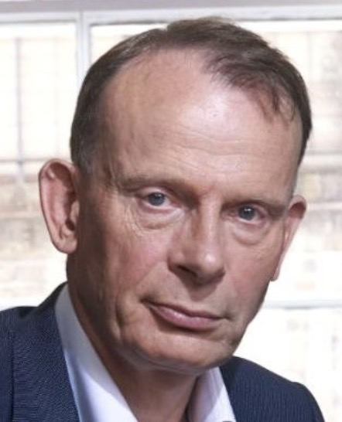 | Churchill was a giant, a huge presence in history, and perhaps our only modern figure to compare with Shakespeare or Darwin. But he was a man, not a deity; when he got it right he was sublime, but he often got it wrong. He changed his opinions; rather than the Age of Churchill, we might perhaps more properly call it the Age of Churchills.  Andrew Marr, 2011
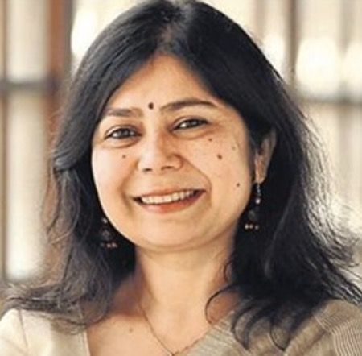 | As a Bengali, I am no fan of Churchill, who was responsible for allowing three million people to starve during the Bengal famine of 1943 by diverting grains to Europe. When parliament reminded him of the deaths, his comment was to ask why Gandhi had not died yet. Parliamentarians, rightly, then and now, have questioned his morality and place in history.  The Indian writer Shrabani Basu, 2019
Churchill defies easy categorisation – to put a label on him such as ‘hero’ or ‘villain’ divorces him from his historical, personal, and political context. On the one hand, he proved himself to be an indefatigable war leader and inspirational orator who held together a national and international alliance that was under considerable strain. On the other hand, he was at times self-centred, made strategic errors and costly mistakes throughout his career and held prejudiced attitudes, particularly on race.
The historian Jacob F Field, 2020

