Head2Head Interview Challenge
Winston Churchill: Hero or Villain?

Extension Task
• Cut out and create a “Diamond 9” Diagram of these images, with the most ‘positive’ images towards the top, and the most ‘negative’ towards the bottom. Explain your choices either in a paragraph or by putting clear captions next to each of the images themselves.
• TIP: Start by writing your captions next to each of the following pictures. Then cut them out, rearrange them as you see fit, and stick them down as a display piece.

 | 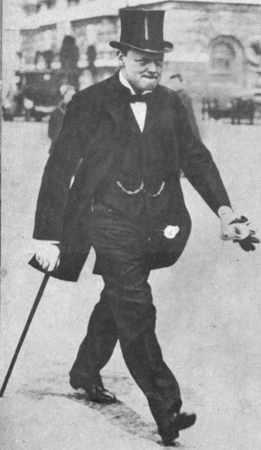 |  | 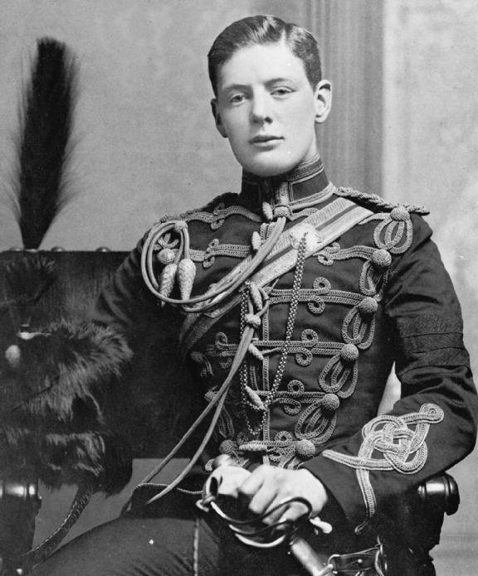
 |  | 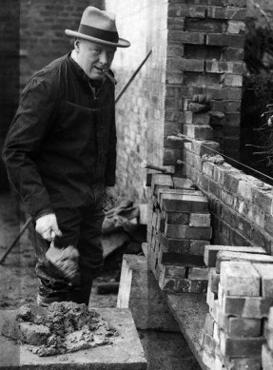
 | 