Head2Head Interview Challenge
Winston Churchill: Hero or Villain?

Teacher Introduction
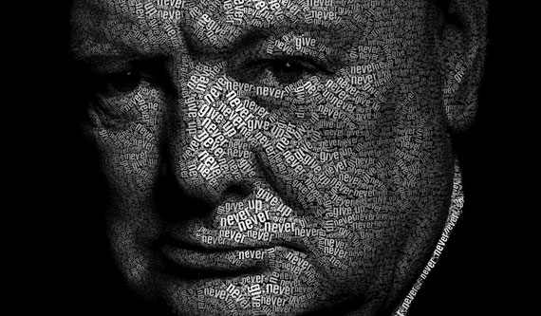
• Winston Churchill is a fascinating and complex historical figure who divides opinion more than perhaps any other person in 20th Century History.
• To his admirers was a radical social reformer and an inspiring visionary who warned against the appeasement of European dictators and saved Britain and Western democracy from what he called a ‘new Dark Age’ of Nazi tyranny.
• To his detractors he was a warmongering, blundering reactionary responsible for such things as the disaster at Gallipoli in World War One, the callous treatment of exploited workers in the General Strike and a failed attempt to spark off World War Three against Soviet Russia in his ‘Iron Curtain’ speech.
• The truth, of course, is that Churchill was all of these things and much more besides. The challenge for historians when deciding if Churchill deserves to be remembered as a ‘hero’ or a ‘villain’ depends on the criteria we choose to use, the evidence we select, and the interpretations we then place on it.

Classroom Introductory Activity – Teacher notes

Pre-class preparation: Divide the whiteboard into two columns.

Quiz Question 1: Who is this?
• To students: “We’ll be investigating the ideas of ‘heroes’ and ‘villains’ in this unit. You might know of the first character we’ll consider. Put your hand up when you think you know who it is, but don’t shout out the answer!”
• At this point, play a sound file of one of Churchill’s speeches (e.g from YouTube).
• Then show the students a series of images of Churchill.
• At the end of the process, ask some of the students whose hands went up earliest for their answers. The correct answer is “Winston Churchill”.

Quiz Question 2: What do we know about him already?
• Conduct a class brainstorm about what the class know about Winston Churchill already – write these in the LEFT-HAND column on the board.
• This could start with the following sorts of questions:
WHO was he?
WHEN did he live?
WHAT was his job?
WHERE was he from?
WHY is he famous?
• We should find here that most if not all of what students know leans towards the positive. You should close the discussion with a few extra choice details: in particular, stressing his reputation as the ‘greatest ever Briton’ who defeated the evil Adolf Hitler and thereby made the world safe for democracy (lay it on thick!).

• When the class has run out of ideas, ask them “Do you think that we should use him as an example of a ‘villain’ or a ‘hero’?” (hopefully they will be pretty unanimous that ‘hero’ is best, although you may have a few dissenters already).
• Write “HERO” at the top of this LEFT-HAND column, and right “VILLAIN” at the top of the RIGHT-HAND column.

Quiz Question 3: Who is this?
• “As your next challenge, I am going to tell you a few things about a historical character from the same period who could be described as a ‘villain’. Raise your hand when you think you might know who he is”.
• Proceed to write the following statements in the “Villain” column on the board:
• He fought in the trenches of World War One
• He led his country during World War Two
• He was well-known for his violent outbursts and terrible temper
• He authorised the bombing of civilian targets in WW2
• He saw no problem in using poison gas against his enemies
• He regarded Indians as an inferior race that should be ruled by white people
• He admitted that he found war exciting invigorating
• His own people turned against him at the end of World War Two

• At the end of the process, ask some of the students whose hands went up earliest for their answers. Several of them might say “Hitler” – and yet the correct answer is in fact again, “Winston Churchill”.

Conclusion / Rounding off
• At the point, explain to the students that like all people, Churchill was a complex mix of good and bad, who had different sides to his personality depending on the time of his life and the people and situations he was going through at the time.
• Our job in this unit is to decide how to measure the true qualities of a ‘heroic’ figure and then investigate how far Churchill lived up to those expectations.
• Whatever conclusions we reach, this process will teach us a lot about Churchill himself, the times in which he lived, our own values and the process of how historians ‘make’ history.

Task for students
At this point, students should use the information on the board to right a paragraph answering the question “Why do some people regard Churchill as a hero, and others regard him as a villain?” (NOTE: this will form the basis of the introduction to their final essay later).

