American Civil War Strategy Game – Part 1

Objective: The winner is the side that captures the enemy capital: Washington DC or Richmond. Through the game you will learn about the key people and areas involved.

Fighting Spirit and Supply: These are rated on a scale of 1 to 12.
• The Confederates start with a Fighting Spirit of 7 and a Supply of 4.
• The Unionists start with a Fighting Spirit of4 and a Supply of 7.

Discussion point: Explain how you think the ratings of each side have been calculated.
▪ On the one hand, the Union has better supplies. They have 22 million people and 90 warships compared to 9 million people and 30 warships in the Confederacy. They also control most of the railways and industry.
▪ On the other hand, the Union has a weaker fighting spirit. They are having to fight the war on enemy ground, and military historians estimate that attacking requires three times the manpower that defending it does. Not only that, but their cause is less clear: the Confederacy are fighting for their independence – the Union is merely denying their right to do so.
Task 1: Role Cards
▪ Students should be given some time to read through the rolecards. Acting “out of character” during the game will confuse the troops and lead to “fighting spirit” points being deducted, so it’s important to reflect on the information presented. It also helps to decide if certain generals would have been likely to act in unison as a joint force (again, if they choose to do so during the game and this is out of character, points can be deducted).

Task 2: Policy Cards
▪ The students should be encouraged to read through all the possible actions and discuss the outcomes of each. To speed things along, encourage them to choose just a couple to start with.

Playing the Simuation
I use the PostIt tool at Classtools.net to set up the armies around the board: I set this up before the lesson ready for the game (the example below is from a game in progress).
▪ At the outset of the war, all the Confederate Armies are in the Richmond zone; all the Republican Armies are in the Washington zone.

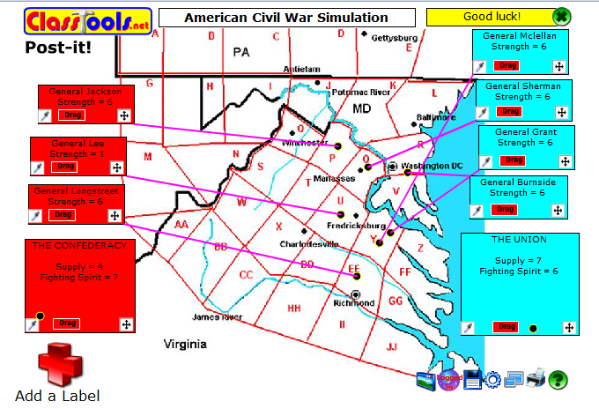

Presidential Round
▪ At the beginning of the first round, each of the two Presidents will make a policy decision designed to increase the Fighting Spirit and/or the Supply of their armies by up to 3 points.
▪ The opposing team can try to convince the teacher that this is not a convincing argument.
▪ The teacher will then decide how strong the argument is and roll a dice to determine if the team wins its points:

Strength of argument according to teacher | Die Roll Needed to Succeed (ie your appropriate rating increases by one point).
Very Strong | 2, 3, 4, 5, 6
Strong | 3, 4, 5, 6
Average | 4, 5, 6
Weak | 5, 6
Very Weak | 6
Impossible | Make up another argument

Generals’ Turns
▪ With the overall strength of each side now determined, we move on to the Generals.
▪ Stress that
▪ The objective of the game is to capture the enemy capital.
▪ If two or more opposing armies are in the same zone, a battle occurs
▪ Any army defending the capital has an extra 4 fighting spirit points

▪ Next, each General takes it in turn to move their forces. The original game allows each army to move one square in any direction, but I adjusted this to allow each army to move two squares to speed things up. Armies can treat the whole sea area as one square, but only the Union (which has a much larger navy) can use it.

▪ If a General moves into a space occupied by enemy forces, it is presumed he is prepared to engage in battle. The enemy General is then asked whether he chooses to engage in battle, or to withdraw one square. Battles will be decided as follows:

The battle strength of each side is calculated (Die Roll + Team Fighting Spirit + Team Supply + Individual Army Strength). The highest total is the winner.
• One strength point is taken from the force(s) of the winning commander(s) in the area.
• Two strength points are taken from the defeated force(s) in the area, which must also immediately retreat one area.
• In the event of a tie, each side loses one strength point and neither side has to retreat.
If an army is reduced to zero strength it is removed from the battlefield. The members of that team should join one of the remaining teams.

▪ After each move, the opposing team has the option to challenge that move if it appears ‘out of character’ – e.g. McLellan adopting an offensive strategy. In this case, the teacher can declare that the General’s troops are disconcerted by this and “army strength” points can be deducted.

Other points and observations
▪ The game will be played over several rounds.
▪ The Generals can make “arguments” to increase the strength of their armies in susequent rounds if there is time for this; similarly, the Presidents may choose to adopt a policy which is designed to increase the strength of a particular army.
▪ The maximum strength for “Fighting Spirit”and “Supply” ratings is 12.

Other Rules
▪ The President can overrule his generals and order them to act differently, but this costs his side 1 Fighting Spirit point.

