Year 9 History: Summer Examination

5 minutes – 5 marks available
Answer the following question
a. Who was Abraham Lincoln?
a. Who was Jefferson Davis?
a. Who was Frederick Douglass?
a. What was the Fugitive Slave Act?
a. What was the cotton gin?
a. Who was William Lloyd Garrison?
a. What was ‘Bleeding Kansas’?
a. What was the ‘Missouri Compromise’?
a. Who was John Brown?
a. Who was Dred Scott?
a. Who was Harriet Beecher Stowe?
a. What was the Underground Railroad?
a. What was the Gettysburg Address?

15 minutes – 7 marks available
Answer the following question
b. Give THREE reasons why the American Civil War break out in 1861.

20 minutes – 8 marks available
Answer one of the following questions
c. Here are four reasons why the Union won the American Civil War in 1865:
i. The mistakes and weaknesses of President Davis
ii. The policies and strengths of President Lincoln
iii. The role of other individuals
iii. Factors outside of anybody’s control
Which of these is most important, and why? Explain your answer by considering and linking together all three factors in as much detail as you can.

c. Here are three reasons why the Union won the American Civil War in 1865:
i. Social and Economic Factors
ii. Political Factors
iii. Military Factors
Which of these is most important, and why? Explain your answer by considering and linking together all three factors in as much detail as you can.

5 minutes – 5 marks available
For a further 5 possible points, identify the following 10 people who you have learned about this year.

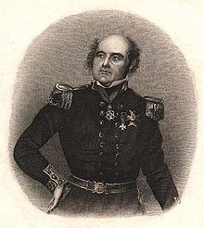 | 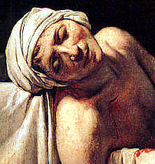 | 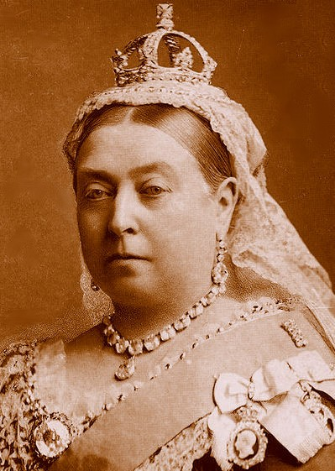 | 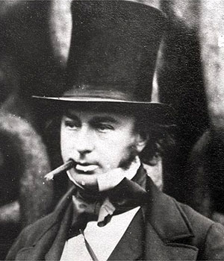 | 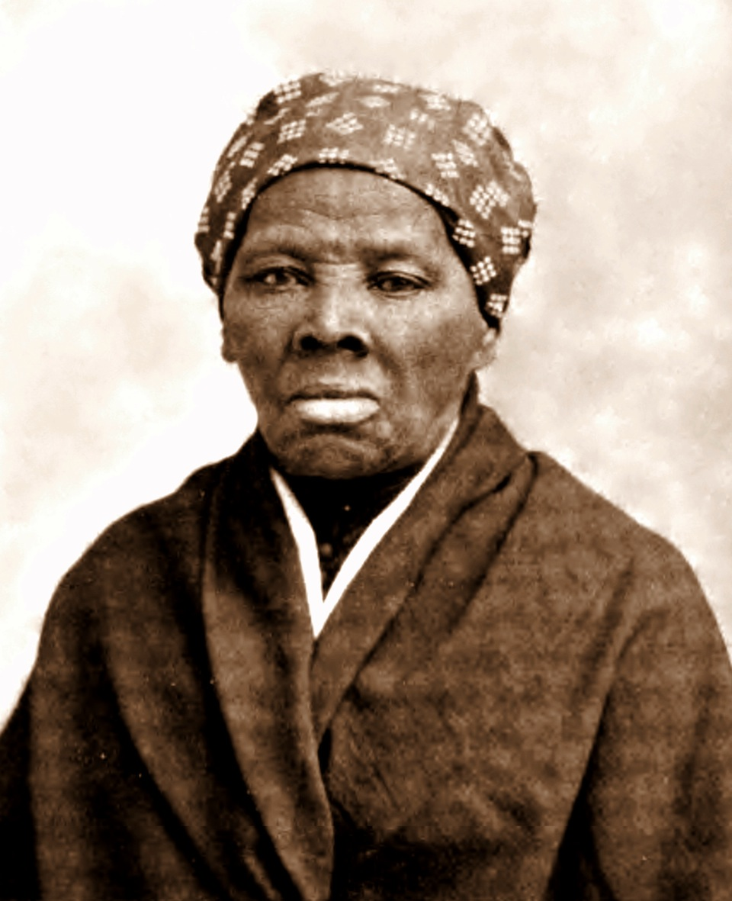
Sir John Franklin | Marat | Victoria | Brunel | Tubman
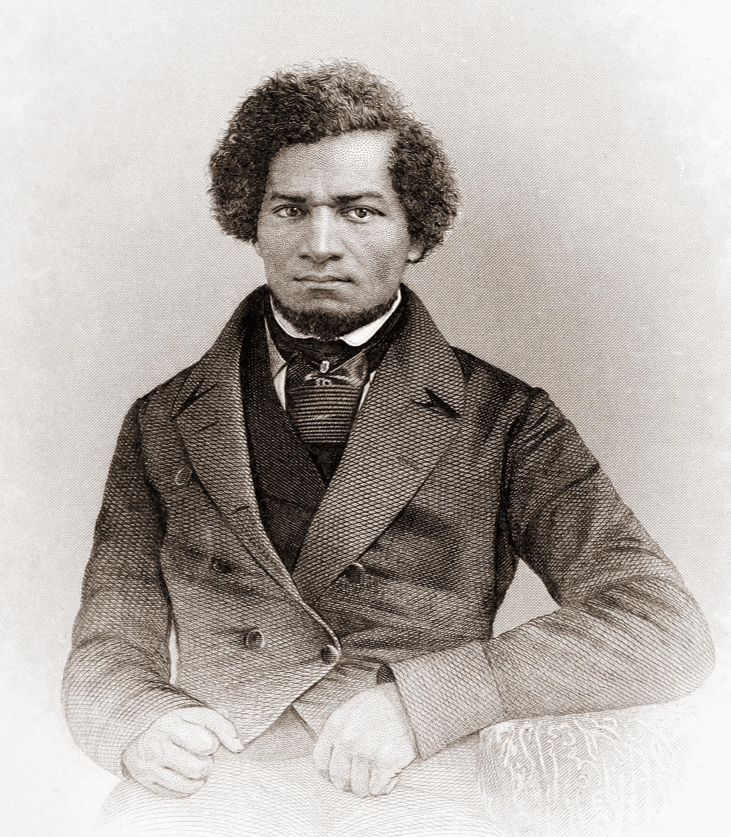 | 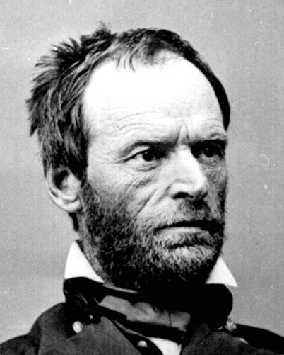 | 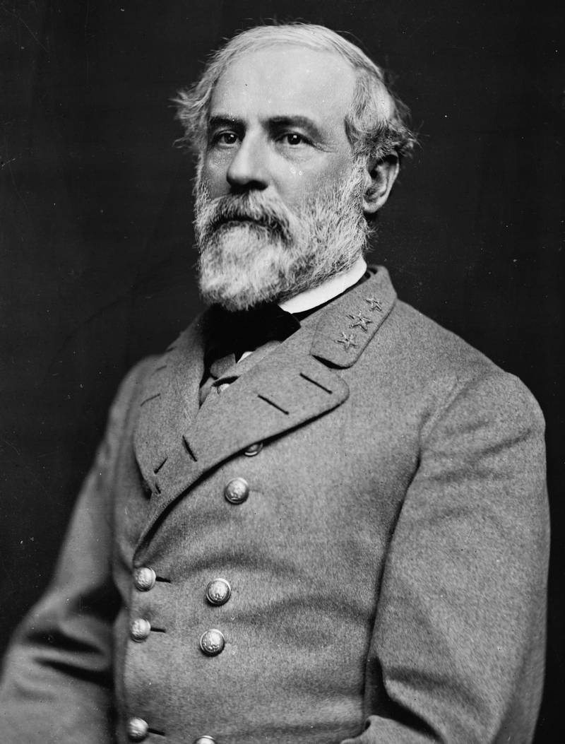 | 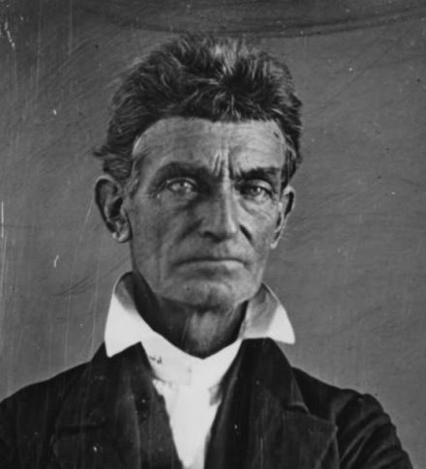 | 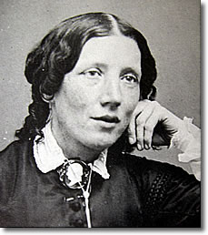
Douglass | Sherman | Lee | Brown | Beecher Stowe

