Stalin’s Henchmen
As your studies continue, you should know the main figures in the USSR: their role, personality and relationship to Stalin.

Task
1. Play the “Splat the Stalinist” game at www.activehistory.co.uk. As you play, make notes about each of the characters using the table overleaf to help you.

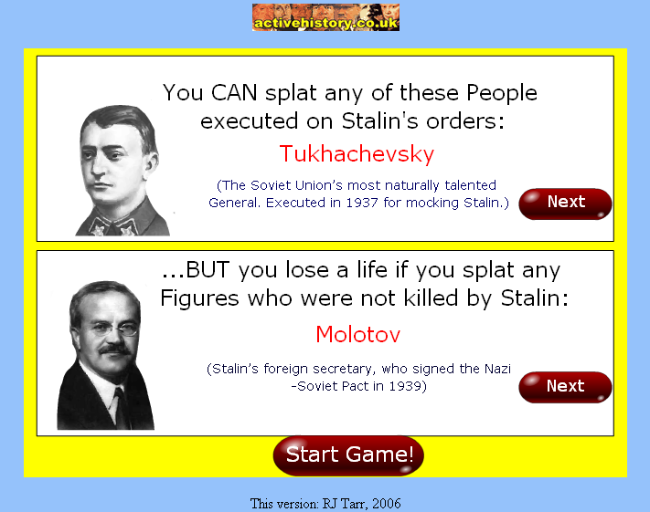

2. Then, conduct some extra research of your own to “flesh out” each character. Keep each profile very brief, focusing just on useful details (job, relationship to Stalin, achievements and failures etc).

3. Finally, as a homework exercise you need to produce an A3 diagram entitled “At the Court of the Red Tsar” (after the fantastic book by Montefiore which I will shamelessly promote given any opportunity). You need to decide:
• How many characters from the list to include (you can leave some out, perhaps because you know about them already, or because you do not consider them particularly important)
• How you are going to arrange / link / colour code them (By job? By relationship to Stalin? By seniority? etc)
• What details you are going to include about each character (these should be the same for each – e.g. born/died, job, success, failure, quote or whatever).
• It is a good idea to include a picture of each character in your diagram. Putting a face to a name is very useful when we come to look at photographs and posters.

STALIN'S HENCHMEN

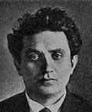 |  |  |  | 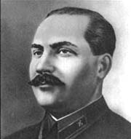
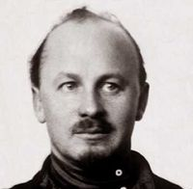 |  |  |  | 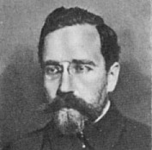
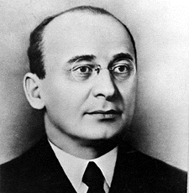 |  |  |  | 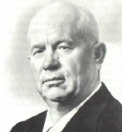
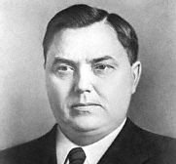 |  |  |  | 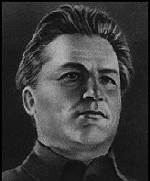
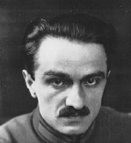 |  |  |  | 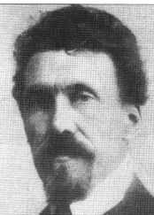
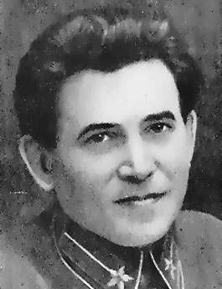 |  |  |  | 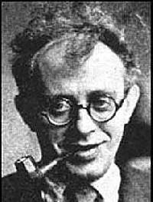
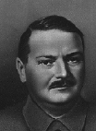 |  |  |  | 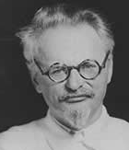
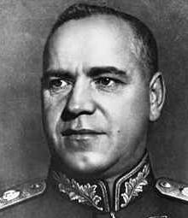 |  |  |  | 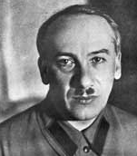
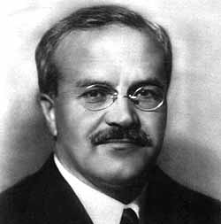 |  |  |  | 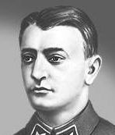
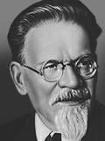 |  |  |  | 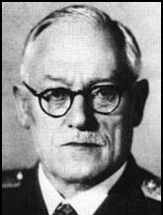
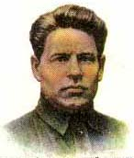 |  |  |  | 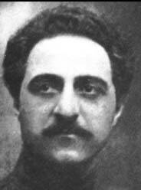
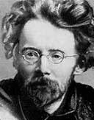 |  |  |  | 