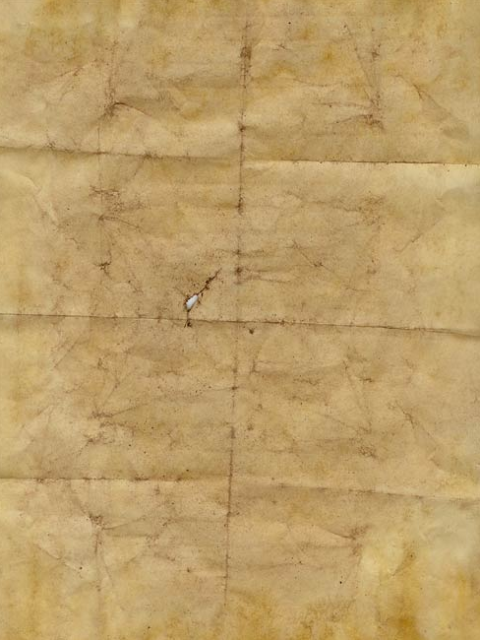
POLICE NOTICE: WANTED
John Smith
Otherwise known as “Jack the Ripper”
p
 | The Suspect | Our reasons
Age |  | We believe that the murderer fits this profile because…
Appearance
?
?
?
?
?

