Humanities Essay Skills
Identify  Make a list of key features, factors, events, people etc. | 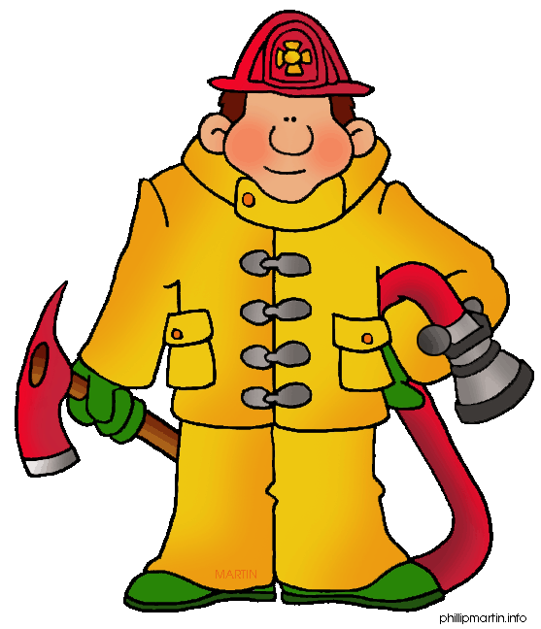
For example...
Q:
Identify what the fire-fighter is wearing.
A:
- A helmet
- A jacket
- Trousers
- Boots
- Gloves

Humanities Essay Skills
Describe  Say what happened, using evidence (examples) to support your ideas. |  | 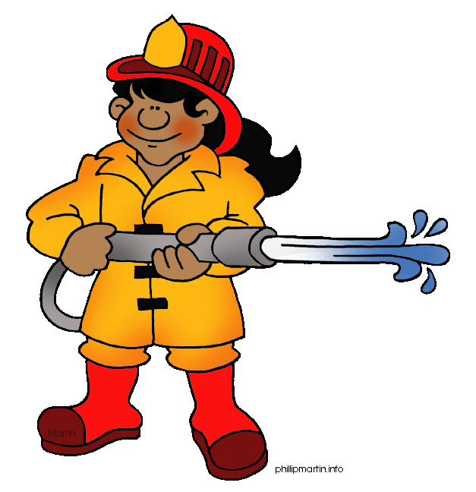
For example...
Q:
Describe what the fire-fighter is wearing.
A:
The fire-fighter is wearing protective clothing. For example she is wearing a red helmet which will be made of something hard. She has rubber wellington boots on. These are red too.
Humanities Essay Skills
Explain
Give reasons for something
For example...
Q:
Explain what the fire-fighter is wearing.
A:
The fire-fighter is wearing a helmet because it protects his head in hazardous situations. His job is to put out fires, which is very dangerous. This means that he needs to protect himself.

Humanities Essay Skills
Analyse
Break the issue down into parts and look, in depth, at each one. In some enquiries you will also have to look at different views, explaining arguments for and against an idea.
For example...
Q: Analyse what the fire-fighter is wearing.
A: The fire-fighter’s job is to go into burning buildings, which may be structurally unsound. This means that things might start breaking up and falling down. Therefore, the fire-fighter wears a helmet to protect her head because her job is hazardous and she needs to protect herself.

The fire-fighter is also wearing boots, which look as though they have reinforced caps over her toes. This is another element of protective clothing. The caps will protect her toes from things that might fall or that she might walk into. The smoke from a fire would limit visability so wearing this type of footwear will protect her when walking on or over hazardous items.
Humanities Essay Skills
Evaluate
Give your verdict. Come to a final conclusion. Make a final judgment. You need to explain your ideas, basing your decision on what you judge to be the most important or significant factors and justify how your decision was made.

Remember, you will have needed to analyse the information before you can evaluate it properly!
For example...
Q: Evaluate how effective a fire-fighter’s uniform is.
A: In conclusion, I think that a fire-fighter’s uniform is extremely effective because if protects them from the hazards they will be facing...

Key Humanities Skills
- How can you get top marks in your humanities lessons?
- Do the targets your teacher set always make sense to you?

Read the description cards to help work out what key words mean. Each one explains what skills you are required to demonstrate and gives an example. Remember, you’re not going to be asked about fire-fighters’ uniforms in any humanities exam.! These examples are just to illustrate the kind of detail you need to prove that you have mastered that particular skill.

Skill: | Identify | Describe | Explain | Analyse | Evaluate
KS3 Level: | 3 | 4 | 5-6 | 6-7 | 7-8
GCSE Grade: | E | D | C-B | B-A | A-A*

Remember that the issues you will examine at GCSE are likely to be more complex than those that you study at KS3.
And don’t forget to revise! It doesn’t matter how good you are at a skill, if you don’t know your stuff you won’t be able to demonstrate your ability!

